In this task you will be updating a home. Part of this task will be using the floorplan below, and the options on the back. You can rip off this page if you would like so that you are not flipping back and forth.

- All measurements are in feet
- The bathroom is 12 feet by 9 feet
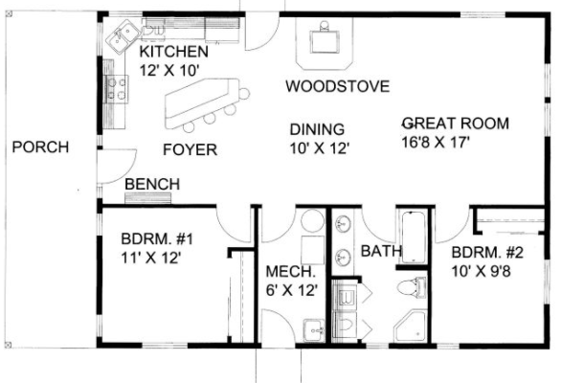
9.5’

Mr. Smith has given you 4 options each for flooring, tile, and crown moulding. You must pick a different option than the people you work with. You may help each other with the process, but you will all have different renovation costs.

Choose one flooring, tile, and backsplash option below:

Flooring Options
Dark Oak | Bamboo | Maple | Dark Walnut
Tile Options
Terra Cotta | Granite | Ceramic | Rough
Crown Moulding Options
Ultra Modern | Ornate | Craftsman Style

1) New flooring is going into the living room, bedroom, bedroom closet, and the two closets in the bedroom hallway. The hardwood costs $7.50 per square foot (including installation). Find the cost of this job:

Room | Area | Cost of Hardwood
Living and Dining Room
Bedroom
Bedroom Closet
Hallway Closet 1
Hallway Closet 2
Total Cost

b) New tile is going into the kitchen, bathroom, utility closet, and the closet by the main entrance. The tile costs $7.75 per square foot (including installation). Find the cost of this job:

Room | Area | Cost of Hardwood
Kitchen
Bathroom
Utility Closet
Entrance Closet
Total Cost

c) Trim is being put along the baseboards in the living and dining room, and the bedroom. This costs $1.25 per foot. Find the cost of this job.

Room | Perimeter | Cost of crown molding
Living and Dining Room
Bedroom
Total Cost
d) What is the total cost of all of these jobs? Include 13% for sales tax.

2) You are pricing out a new roof for your home. You have a “hipped roof” diagrammed below. Find the total area of your roof using the table below.

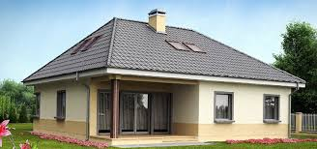
Visual of Roof:
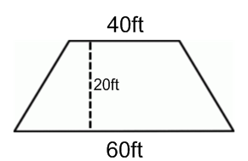
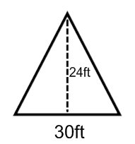
Area of Triangle Portion (calculations) | Area of Trapezoid Portion (calculations)
Area = | Area =
Total Area (2 triangles + 2 trapezoids) =

b) The cost for metal roofing is $9.00 per square foot (installed). How much is this new roof going to cost?
3) Mr. Smith is putting up a backsplash in his kitchen. The wall where the backsplash is going looks something like below. The wall itself is 5 feet by 10 feet. In addition, the 3 cabinet sizes are listed below:

- Cabinet type A is 2 feet by 4 feet
- Cabinet type B is 2 feet by 2 feet
- Cabinet type C is 1 foot by 2feet
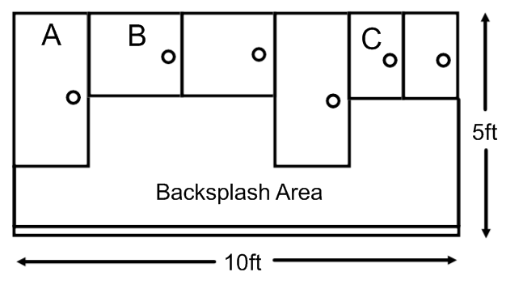

Determine the area of the backsplash wall:

Shape 1: | Shape 2: | Shape 3:
Area = | Area = | Area =
Total Area =

