In this unit we covered:

- Perimeter
- Area
- Pythagorean Theorem
- Applications

Tomorrow, you will price out some home renovations using your knowledge of 2D Measurement. We will review the main concepts together, and then you will work on some preparation questions after.

We started out looking at perimeter:

The general formula for perimeter is:

Circles have specific formulas for their perimeter (circumeference):

Perimeter would be required in household applications like:

- Trim
- Crown Moulding
- Fencing

Try finding the perimeter of the following shapes:

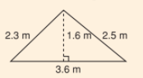
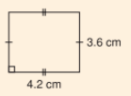
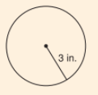
a) b) c)

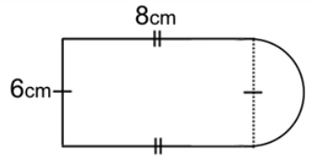
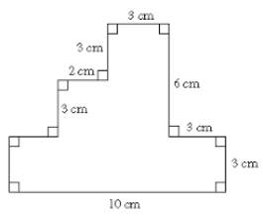
d) e)

We then reviewed the Pythagorean Theorem, which helps you find the longer side (hypotenuse) in a right angle triangle.
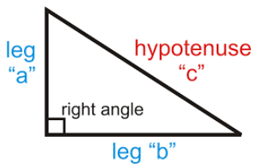
Formula:

Example: Find the length of the long side (hypotenuse) in this right angle triangle.

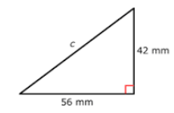

This is actually a 3-4-5 triangle (scaled up by 14). Remember that 3-4-5 triangles are always 90 degrees, which is very helpful in construction applications.

We then talked about area:

Different shapes have different specific formulas:
$A_{rect}=l×w$ $A_{tri}=b×h÷2$ $A_{trap}=(top+bottom)×h÷2$

$A_{circ}=π×r^{2}$
Area would be required in household applications like:

- Flooring
- Painting
- Staining
- Carpeting
- Laying Tile
- Landscaping

Determine the area of the following basic shapes:
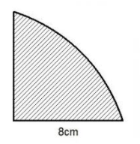
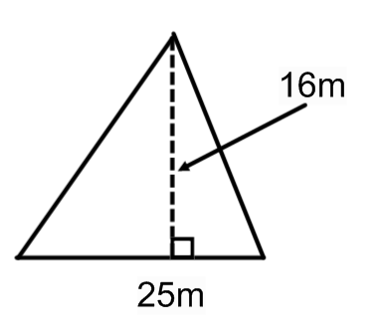
a) b)

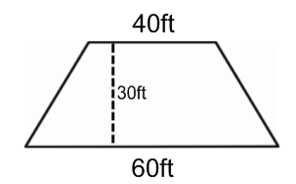
c) d)

Many shapes around a home are composite shapes. To find the area of composite shapes, we found the area of all the basic shapes that make it up.

a) Consider this irregularly shaped room drawn below.

Diagram
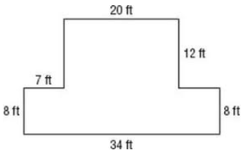
Basic Shape #1 | Basic Shape #2
Area = | Area =
Total Area =

