Note: All relevant formulas are on yesterday’s review note.

In this task you will be applying 3D measurement concepts to applications around the home:

- Filling a pool
- Creating a garden
- Heat a garage
- Paint a garage

1) [10 marks] a) Mr. Smith is planting a rectangular garden in his backyard. The garden will be 6 feet long, 15 feet wide, and 2 feet deep. How much cubic feet of soil will be needed to fill the garden?
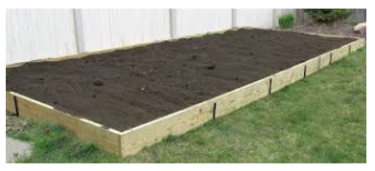

b) Mr. Smith is getting some soil delivered in bulk to his driveway. The delivery takes several trips. One truckload of soil forms the conical pile shown below. How much cubic feet of soil is in one of these piles?
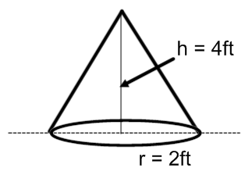

c) How many truckloads will he need to complete his garden? Use your answers from a) and b).

d) One truckload of soil costs $135. How much will Mr. Smith pay for the soil to fill up his garden? Include a 13% sales tax.

2) [10 marks] The dimensions of an irregularly shaped pool are shown in the diagram below.

a) Find the area of the pool surface:

Diagram of Pool Surface
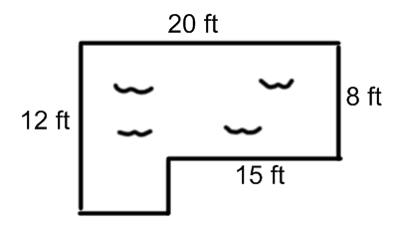
Basic Shape #1 | Basic Shape #2
Area = | Area =
Total Area =

b) The pool is 5 feet deep. Use the formula: $V_{prism}=Area of Base ×Height of Prism$ to find the volume of the entire pool.

c) 100 cubic feet of water costs about 5$ on your hydro bill. How much would it cost to fill up this pool? You do not need to include sales tax on utilities like water.

3) [10 marks] You are helping a friend build a work shed in their backyard. The shed is very simple in design, with a rectangular prism base, and a triangular prism roof. The dimensions of the shed are shown in the diagram below.

a) Find the volume of the shed.

Diagram of shed | Basic Shape 1 | Basic Shape 2
Sketch:

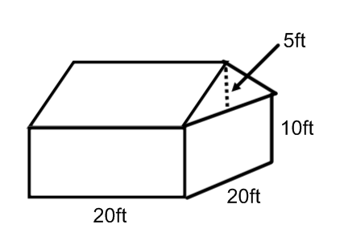
 | Volume = | Volume =
Total Volume =

b) Your friend is going to heat this shed all year round. Heating a home costs $15.90 per year for every 1000 ft³. How much will it cost your friend to heat their shed all year round? Sales tax is not included in utilities.

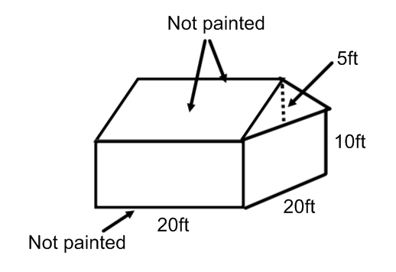
4) Finally, you are going to help your friend paint the shed. For obvious reasons, the bottom will not be painted. The roof will not be painted either. All outward facing surfaces will be painted however.

a) Find the surface area of the shed that will be painted.

b) 1 gallon of paint ($50) will be able to cover 100 ft². You plan on applying only 1 coat of paint to the shed. How much will it cost to paint the shed? Include 13% sales tax in this calculation.

