Consider the triangle formed by A(-4, 1), B(3, 8), and C(6, -3). You already started working with this triangle today.
Put the equation into the table below, redraw your triangle, and add this altitude to your graph.
Equation of Altitude from AB
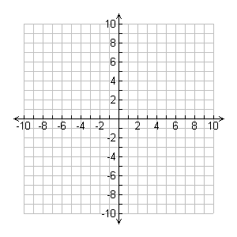

1) Find the altitude from BC, using the folowing steps:

a) Find the slope of BC.
b) Find the slope of the altitude. Draw the altitude on the graph.

c) Find the equation of the altitude using the slope from b) and point A. When you are done add it to your graph.

Equation of Altitude from BC
2) Find the altitude from AC, using the folowing steps:

a) Find the slope of AC.
b) Find the slope of the altitude. Draw the altitude on the graph.

c) Find the equation of the altitude using the slope from b) and point B. When you are done add it to your graph.

Equation of Altitude from AC

3) Pick two of your altitudes, and determine the point of intersection. This is the orthocentre!!!
Altitude #1 |  | Altitude #2

The orthocenter is… | ( , )

3) In this question, you will all randomly choose your own quadrilateral and verify that the midpoints of your quadrilateral form a parallelogram.
a) Pick 4 points to form a quadrilateral. They must be different than your seat partners, and no points should line up vertically or horizontally. Draw the quadrilateral on your graph.
Point A |  | Point B
Point C |  | Point D

b) Find the following 4 midpoints, add them to your graph, and draw the corresponding quadrilateral.
Midpoint of AB (E): | Midpoint of BC (F):
Midpoint of CD (G): | Midpoint of DA (H):

c) Find the slopes of the 4 sides of your new quadrilateral:
Slope of EF: | Slope of FG:
Slope of GH: | Slope of HE:

Did you get two pairs of parallel sides? If so, good job! You’ve shown that those 4 midpoints form a parallelogram. If not, go back and check your work.

Level R | Level 1 | Level 2 | Level 3 | Level 4
Task is incomplete. Work is very unorganized and hard to follow. Mr. Smith may ask you to redo it. | Calculations have major errors. Work is somewhat organized. Instructions were not followed well. Major notation issues. | Calculations have minor errors. Work is somewhat organized. Minor notation issues. Instructions were followed for the most part. | Calculations have minor errors. Work is organized. Proper notation is used. Instructions were properly followed. | All calculations are correct. Work is well organized and proper notation used. Instructions were followed meticulously.

