Key Concept Questions:
1) Given 2 points $\left(x_{1},y_{1}\right) and (x_{2},y_{2})$….
a) What is the formula that gives you the slope between the two points?
b) What is the formula for finding the midpoint of the two points?
c) What is the formula for the distance between the two points
*These formulas will be given, but you should know them!*
2) What is the equation for a circle with a center of (0, 0) and a radius of r?
3) Given the equation of a circle, how can you tell if a point lies inside the circle, on the circle, or outside of the circle?
4) What is a median of a triangle?
5) What is the right bisector of a line segment?
*You will use your basic knowledge of these to solve more involved questions. Such as finding the shortest distance from a point to a line, or verifying properties of triangles and quadrilaterals.
Text Review Questions:
Completing as many as following problems will help you get ready for your test on Friday. On Wednesday, Mr. Smith will have a practice test ready for you to give you an idea of what the actual test will be structured like.
On top of the practice test, do as many of these review questions as you can. Work on the problems you feel you need work on.
page 100 #1, 2, 3, 4abd, 6, 7, 8, 9ab, 10, 11, 13, 14, 15, 16a, 18
page 104 #1, 2, 3, 4, 5, 6, 8abcd, 9ab, 11, 12abc
You may also wish to:
- Reread/scan through each chapter we covered
- Reread/copy out the Key Concepts section of each chapter
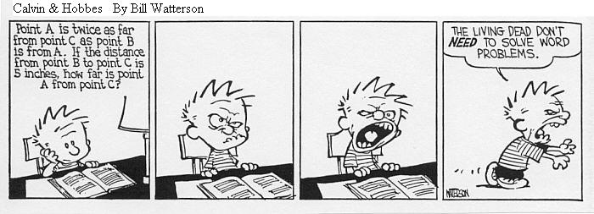
- Scan through your notes
- Come for extra help!

