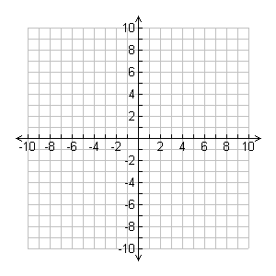
1) Determine whether the triangle with vertices A(-3, 4), B(-1, -2), and C(3, 2) is isosceles. Hint: Will you need to calculate slopes, midpoints, or lengths?

2) A triangle has vertices E(2, -2), F(-4, -4), and G(0, 4).

b) Determine the length of the median from vertex E.

3) Determine the shortest distance from the point E(1, -4) to the line through points F(-5, 2) and G(3, 4). Use a diagram to check your answer.

