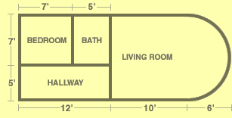
Consider this floor layout in an apartment:
Level:

1) Calculate the area of each individual room. Show the calculations that you are using. More space has been given for the living room calculation, since it involves a rectangle and a half-circle.

Bedroom: | Bath: | Hallway:
Living Room:

2) New sub-flooring will be going under the entire floor. What is the area of the entire floor? Use your answers from question 1).

3) The landlord of the apartment wants to make the following updates to the apartment:

- Hardwood flooring in the bedroom and hallway (30$ per square foot)
- Tile in the bathroom ($15 per square foot)
- Soundproof and waterproof sub-flooring in every single room ($5 per square foot)

Complete the following table to get the cost of the updates:

Hardwood Costs
Bedroom Area | Bath Area | Hallway Area | Living Room Area | Total Area | Cost of Hardwood
 | N/A |  | N/A
Tile Costs
Bedroom Area | Bath Area | Hallway Area | Living Room Area | Total Area | Cost of Tile
N/A |  | N/A | N/A
Subfloor Costs
Area of entire floor |  |  |  |  | Cost of Subfloor
Total Costs of Materials

