Today we will be constructing graphs in Google Sheets. By the end of today you will have made 5 different graphs:

- Bar Graph
- Double Bar Graph
- Line Graph
- Double Line Graph
- Circle Graph

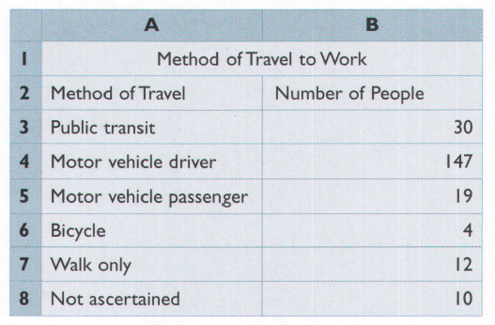
We will reproduce some graphs we made in class last day, and also make some new ones!
Example 1: Jeremy does research for an environmental group. He interviewed 222 people about their methods of travel to work. The environmental group wants to collect statistics for a presentation to the government on improving public transportation.
a) Construct a bar graph to display the results. Label the graph “Method of Travel to Work.” Label one axis “Method of Travel” and the other axis “Number of People.”

b) How might the environmental group use the data to request improvements to public transportation?

 | Male | Female
Grade 9 | 23 | 32
Grade 10 | 26 | 35
Grade 11 | 34 | 33
Grade 12 | 32 | 31
Example 2:
Susan wants to create a graph to compare how males and females in different grades are participating in clubs at school. She collects the following data for the number of students in clubs/teams:
a) Create a double-bar graph to display the student involvement. Label one axis “Grade” and the other axis “Students Involved”. Use a legend to show which bars represent males, and which represent females.

b) The student success department wants to figure out who to target to get more people involved in clubs/teams.
i) Do they need to target all grades? ii) Do they need to target males and females?
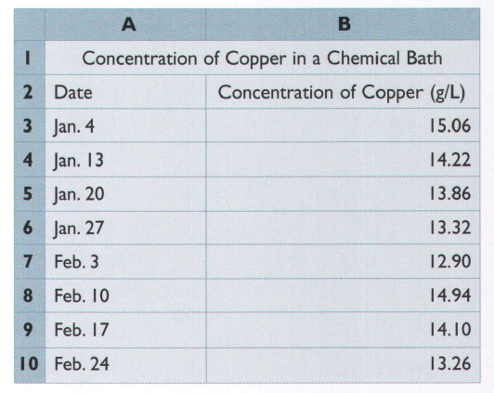
Example 3: Kafal works in a factory that plates copper onto printed circuit boards. She measures the concetration of copper in the chemical bath every week and compares the results. The spreadsheet shows the data for January and February.
a) Construct a line graph to display the data. Label the graph “Concentration of Copper”. Label one axis “Date” and the other “Concentration of Copper (g/L).

b) When was the concentration increasing?

c) When was the concentration decreasing?

d) Explain why a line graph is suitable for displaying this data.

