Days | Vanilla | Chocolate
Monday | 50 | 50
Tuesday | 60 | 80
Wednesday | 40 | 60
Thursday | 50 | 50
1) Create a double-bar graph to display the ice cream sales illustrated in the table at the right. Label the graph “Ice Cream Sales”. Label one axis “Day” and the other axis “Ice Cream Cones Sold”.
Use a legend to show which bars represent vanilla, and which represent chocolate.

2) What type of graph would you use to display each of the following types of data? Each type (bar graph, double bar graph, line graph, double line graph, circle graph) will be used once.
Type of Data | Which Type of Graph?
The percents of your allowance that you use for savings, personal expenses, charity, and entertainment
The number of hours you spend on math homework each week for a term
Average test scores in reading, writing, and math for your school
Average test scores in reading, writing, and math for your school compared to the average test scores in those subjects for all
Schools in the province
the number of hours you spend on math homework each week for a term compared to the time you spend on English homework
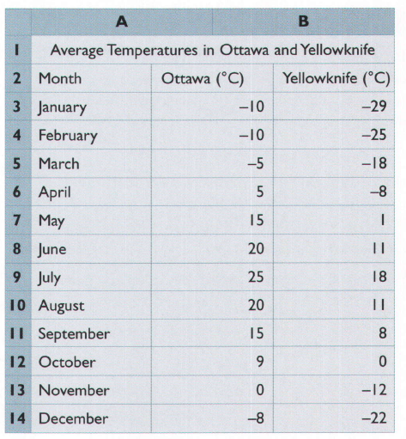
3) [10 marks] The spreadsheet at the right shows average temperatures in Ottawa and Yellowknife in degrees Celcius.
a) Construct a double line graph to display the data. Label the graph “Average Temperatures in Ottawa and Yellowknife.” Label one axis “Month” and the other axis “Average Temperature”.
Use circles for Ottawa, and squares for Yellowknife (as the legend indicates).

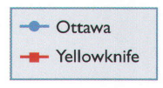

b) When and where were the temperatures highest and lowest?

c) When was the greatest difference in temperature between the two cities? When was the least difference?

d) Explain why a double line graph is suitable for displaying this data.

