You should do your best to complete this assignment today. You have the entire period to work on it today, and after that it will be homework. Round sides to one decimal pace, and angles to the nearest degree. If you finish in class, Mr. Smith will assign you some extra practice. Feel free to work with others, but remember, copying someone’s work will leave you worse off for the final unit test. Include concluding statements for any word problem.
/35
Knowledge and Understanding
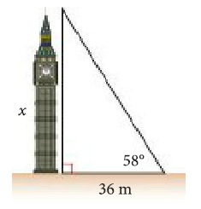
1) Find the length of the indicated side using SOHCAHTOA. each.
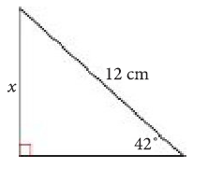
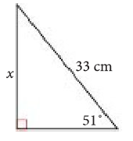
a) b) c)

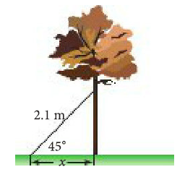
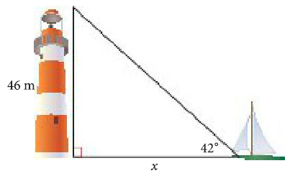
d) e)

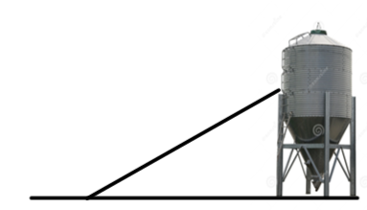
2) A conveyor belt up to a silo needs to make an angle of 8° with the ground. It needs to reach a window that is 6m off the ground vertically.
a) Label the given diagram for this situation.
b) How long is the actual conveyor belt?

3) In this question, you will need to draw your own diagram!
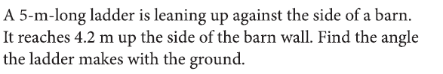

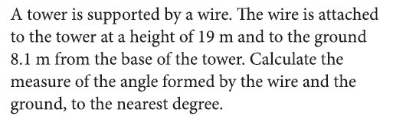
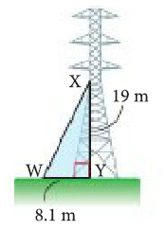
4) In this question, you need to figure out which angle you are asked to find.

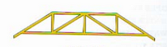
5) The roof truss drawn below is a type of “scissors” truss. The truss forms six identical right triangles, with 1 foot of overhang on each side.
3 ft
y
Using the dimensions given in the diagram, determine how much total lumber would be needed to create one of these trusses.
30°
1 ft of overhang
x
Hint #1: Since all of the triangles in this truss are the same size, you just need to calculate the lengths of the sides labeled with x and y.

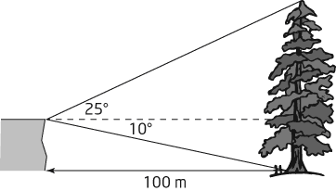
6) From a rock ledge, the angle of elevation to
the top of a tree is 25º. The angle of depression
to the bottom of the tree is 10º.
a) Find the height of the rock ledge to
the nearest tenth of a metre.
b) Find the height of the tree to the nearest
tenth of a metre.

