1. Using your knowledge of vertex form, graph the following quadratic relations.

a)  b) 

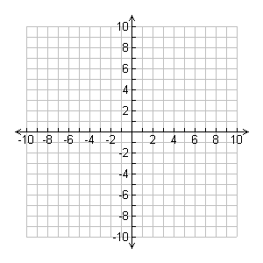Vertex: Vertex:

Step Pattern: Step Pattern:

c) y = - (x + 4)2 + 7 d) y = 2(x – 4)2

Vertex: Vertex:

Step Pattern: Step Pattern:

e)  f) 

Vertex: Vertex:

Step Pattern: Step Pattern:

g) y = -3x2 h) y = 2(x – 6)2 - 5

Vertex: Vertex:

Step Pattern: Step Pattern: