1) Solve the following proportions using the “cross-multiplication” method. Show the calculation you make for full marks. each
/27
a) $\frac{a}{9}=\frac{7}{2}$ b) $\frac{12}{a}=\frac{10}{31}$ c) $\frac{7.5}{2.5}=\frac{b}{14}$

d) $\frac{x}{4.4}=\frac{11}{2}$ e) $\frac{1200}{y}=\frac{15}{23}$ f) $\frac{3}{2.4}=\frac{f}{36}$

Use your conversion table from our note to help with remaining questions:
2) Asher’s track coach has instructed him to do a 3.5-mile run. To visualize how far that is, Asher wants to convert this into yards. Which of the following set-ups could be correct? Choose the correct one, and finish solving.
$\frac{miles}{yards}=\frac{1}{1760}=\frac{3.5}{x}$ OR $\frac{miles}{yards}=\frac{1760}{1}=\frac{3.5}{x}$

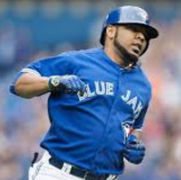
3) One of Edwin Encarnacion’s longest homeruns last season was 460 feet. How far is this in yards? Like the last question, one of these setups is correct. Choose the correct one, and finish solving.
$\frac{feet}{yards}=\frac{3}{1}=\frac{460}{x}$ OR $\frac{yards}{feet}=\frac{1}{3}=\frac{460}{x}$

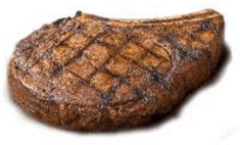
4) When eating red meat, nutritionists advice having a 4 oz serving. How much is that in pounds? Again, choose the correct setup, and finish solving.
$\frac{oz}{lbs}=\frac{1}{16}=\frac{4}{x}$ OR $\frac{oz}{lbs}=\frac{16}{1}=\frac{4}{x}$

5) You try converting the following imperial measures. Set up a proportion like the previous questions. each.
a) Convert 5.5 gallons into quarts b) Convert 20 fluid ounces into pints

6) Mr. Smith’s best throw with his Destroyer disc 350 feet. How many yards is this?

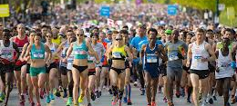
7) A typical marathon is 26.2 miles. How many feet is this? Note: You will need to convert to yards first, and then feet.

