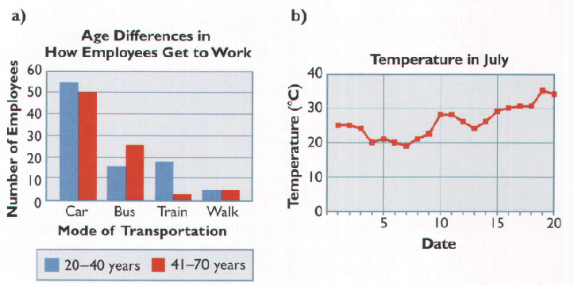
1) Identify the type of graph, explain why each graph is suitable for the data displayed.

Type: | Type:
Reason: | Reason:
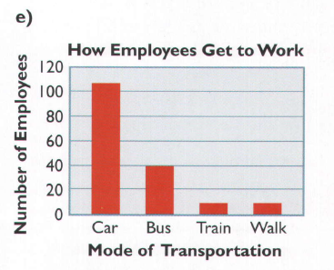
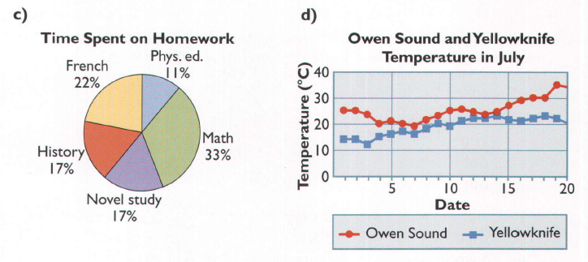

Type: | Type:
Reason: | Reason:

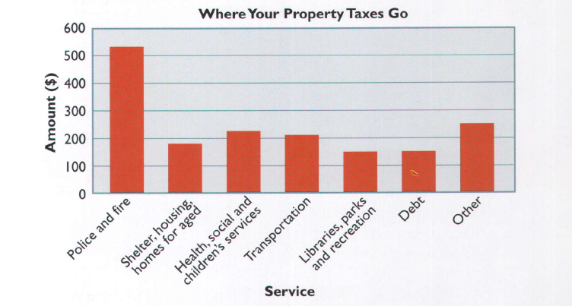
2) The city art department could display the distribution of a certain amount of property taxes in a bar graph, instead of using the circle graph in our note.
a) How are the circle graphs and bar graphs alike? How are they different?

Similarities | Differences

b) Which graph do you think is more suitable for displaying the data? Explain.

3) We will be using percentages a lot with circle graphs. Express each of the following as a percent. Hint: Divide and multiply by 100.
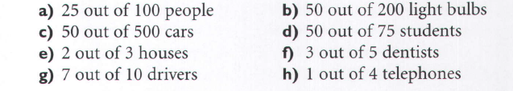
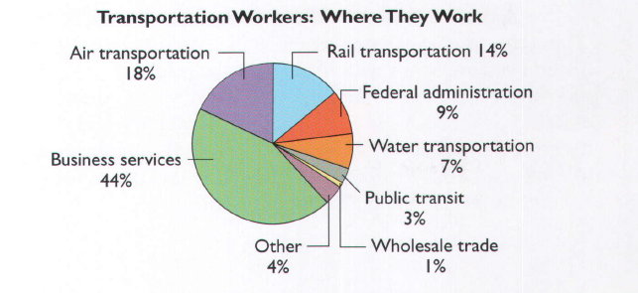
4) In our note, we did a bar graph showing where transportation workers are employed. Displaying only these seven areas of employment in a circle graph would not be meaningful. But you could display these seven areas and “Other” as percents of the total in the pie graph.

a) What do the percentages add to now?

b) Let’s say 200,000 workers in Canada work in the transportation field. Determine the number of workers in each sector.
Sector | Percentage | Number of Workers
Business Services
Air transportation
Rail transportation
Federal administration
Water transportation
Public transit
Wholesale trade
Other
Totals

