Question 1: Basic Lottery Design
/15
In this simple lottery, players choose 5 different numbers from 1 to 40, in a specific order. If the 5 numbers are drawn in the correct order, the player wins this lottery.
a) First determine how many possible outcomes there are:
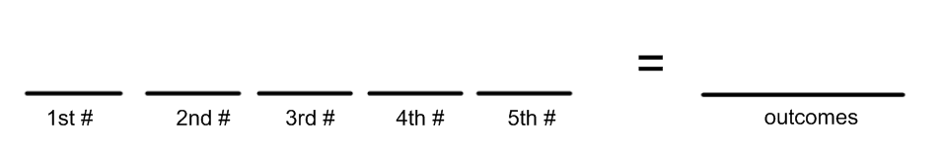
b) What is your chance of winning this lottery?
Fraction | Decimal (4 decimals) | Percentage (2 decimals)

Question 2: Lotto 555
In this lottery, players choose 5 different numbers from 1 to 55. The difference here is, the order of the numbers doesn’t matter, as long as all 5 are correct.
a) First determine how many possible outcomes there are:
b) A lot of these are repeats, since they will contain the same numbers in a different order. The number of ways to arrange five numbers is…
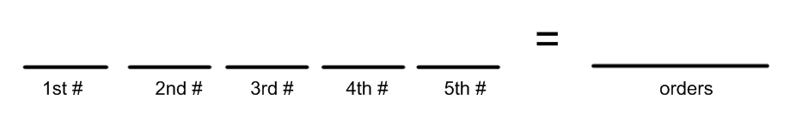
c) Use your answers in a) and b) find the total number of different 5 number combinations:
d) What is your chance of winning this lottery?
Fraction | Decimal (4 decimals) | Percentage (2 decimals)

Question 3: Roll Up The Rim Simulation
In this question you are going to analyze a coffee cup prize scheme. The numbers are loosely based to the 2016 Tim Hortons promotion. Mr. Smith estimated dollar values of certain prizes. The prize breakdown is given below.
a) Complete the following table to determine how much someone who buys a coffee can expect to win in this lottery. Players can use information like this to determine if a lottery is something they want to participate in.
Prize | # of cups | Probability of Winning (as a decimal) | Multiply the prize $ value by the decimal probability
Try Again ($0) | 79,974,710
Food or Drink (2$) | 20,000,000
Gift Card ($100) | 25,000
TV ($2,000) | 150
Prepaid Visa ($5,000) | 100
Car ($50,000) | 40
Totals:

This would give you an idea of the benefit you are getting if you buy a coffee for 2$ or so!
The last think I want you to do today is a short survey on the pros and cons of lotteries. The link is on the course website, or use the tinyurl below, or the QR code below.
Tinyurl: https://tinyurl.com/ycslovde QR Code:

