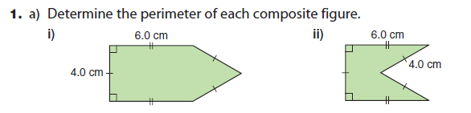

b) What did you notice about the perimeters found in question #1? Do you think the same pattern would hold for their areas? How could you find out?

