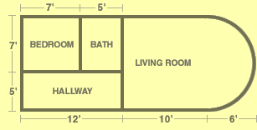
Consider this floor layout in an apartment:

1) Calculate the perimeter of each individual room. More space has been given for the living room calculation. Show your work!

Bedroom: | Bath: | Hallway:
Living Room:

2) Insulation is going to be put in around the outside of the entire floor. What is the perimeter of the entire floor (just the outside walls)? Show your work!

3) The landlord of the apartment wants to make the following updates to the apartment:

- Crown molding ($10 per foot) in the Bedroom and Living Room
- Trim (5$ per foot) in every single room
- Energy efficient insulation (20$ per foot) around the outside of the apartment

Complete the following table to get the cost of the updates:

Crown Molding Costs
Bedroom Perimeter | Bath Perimeter | Hallway Perimeter | Living Room Perimeter | Total Perimeter | Cost of crown molding
 | N/A | N/A
Trim Costs
Bedroom Perimeter | Bath Perimeter | Hallway Perimeter | Living Room Perimeter | Total Perimeter | Cost of trim
Insulation Costs
Perimeter of entire floor |  |  |  |  | Cost of insulation
Total Costs

