In this assignment you will further analyze the game of Plinko with respect to probability. We will begin by continuing our analysis of which slot gives the best chance at 10,000$. Have your calculators ready!
/20
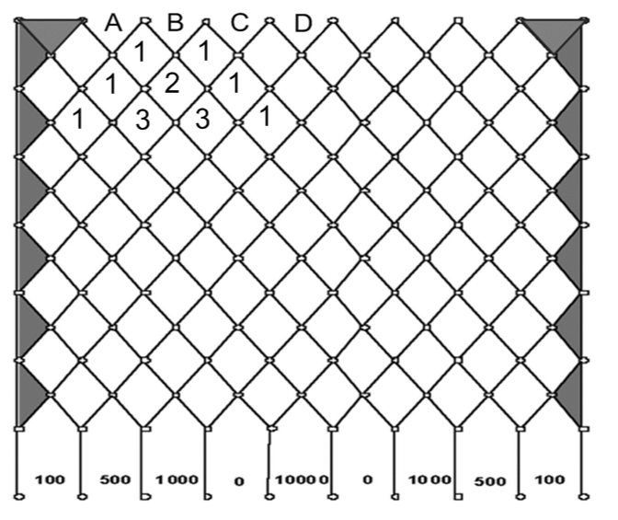
1) Start by finding the probability of winning $10,000 if you drop a chip into slot B.

# of ways to reach bottom: # of ways to reach $10,000 slot:
Probability of winning $10,000 if you drop from slot B:
Fraction | Decimal (4 decimals) | Percentage (2 decimals)
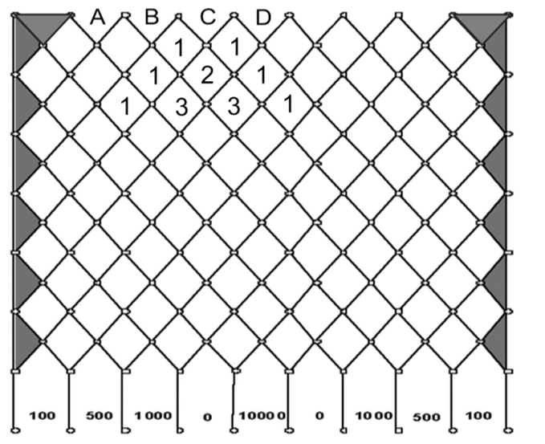
2) Next find the probability of winning $10,000 if you drop a chip in slot C.

# of ways to reach bottom: # of ways to reach $10,000 slot:

Probability of winning $10,000 if you drop from slot C:
Fraction | Decimal (4 decimals) | Percentage (2 decimals)

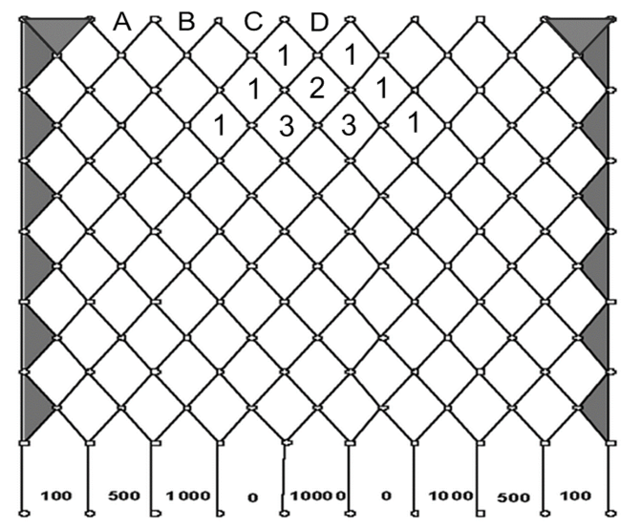
3) Lastly, find the probability of winning $10,000 if you drop a chip in slot D.

# of ways to reach bottom: # of ways to reach $10,000 slot:
Probability of winning $10,000 if you drop from slot C:
Fraction | Decimal (4 decimals) | Percentage (2 decimals)

4) Summary: State the probabilities (as a percentage) of getting $10,000 from each slot.
Slot A | Slot B | Slot C | Slot D
5) If you were dropping a Plinko chip onto the game board, which slot would you drop it in? Explain your choice with complete sentences.

BONUS: Do this section if you are completely done, but it is not mandatory!
6) If a player has 5 chips, we can determine how much money they would make on average by dropping the chips in slot D. We will begin by completing this table for slot D. Note: A sample row has been done for you with made up numbers.
Total # of ways to reach the bottom in slot D: __________________
Finishing slot | # of ways to get to finishing slot (don’t forget to count the 0, 100, 500, and 1000 slots twice) | Probability of finishing in this slot (divide 1st column by # of ways to reach bottom) | # of times hit in 1,000 attempts (multiply 2nd column by 1000) | Money made from this slot (multiply 3rd column by dollar value)
Example (made up $200 slot) | 244 out of 2000 | $$\frac{244}{2000}=0.122$$ | $$0.122×1000 \\ =122 times hit$$ | $$122×\$200 \\ =\$24,400$$
0
100
500
1,000
10,000
Totals (don’t count the example!)

b) How much total money could you make in 1,000 attempts from slot D? ____________________
c) The maximum number of Plinko attempts one player can have in a game is 5. Divide your answer in part b) by 200 to determine the amount that a player can expect to make in 5 drops!

