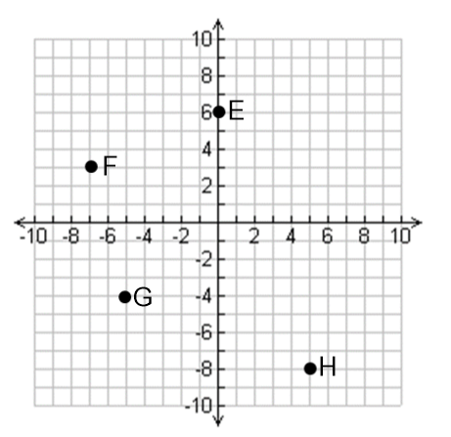

**1.** Plot and label points A 🡪 D on the grid provided.   
Write the coordinates of points E🡪 H.

A (3, −2) E

B (0, 2) F

C (−3, 4) G

D (1, 0) H

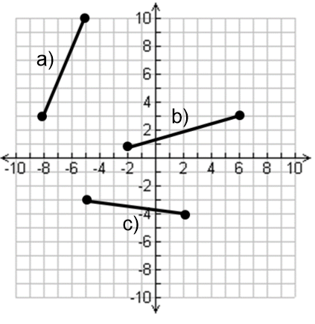**2.**  Determine the slope of the following line segments using: $slope=m=\frac{rise}{run}$

|  |  |
| --- | --- |
| Line Segment a) | |
| Rise = | Run = |
| Slope = | |
| Line Segment b) | |
| Rise = | Run = |
| Slope = | |
| Line Segment c) | |
| Rise = | Run = |
| Slope = | |

**3.** Determine the slope of the line between the points given using the slope formula $m=\frac{y_{2}-y_{1}}{x_{2}-x_{1}}$

**a)** (1, 2) and (5, 7) **b)** (−2, 7) and (5, 14) c) (4, 5) and (10, 5)

**4.** Answer the following questions about the equation of the line.

|  |  |  |
| --- | --- | --- |
| 1. State the slope (m) and y-intercept (b) for the line   m = _______  b = _______ | **b)** Write the **equation of the line in y = mx + b** form with a slope of –2 and a  y-intercept of 7.  y = _________________ | **c)** State the equation of the line in y = mx + b form if the line has a slope of 2 and the same y-intercept as .  y = _________________ |

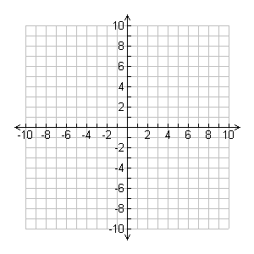5. Graph each line on the grid provided.

a) m=__________

b=__________

b) m=__________

b=__________

6. Find the **equation** in **y = mx + b** form of the lines that satisfy the following properties. Graph the information first, that should help you figure out what the y-intercept is.

a) With a slope of $\frac{1}{2}$, through (4, 3) b) Through the points (-8, 6) and (-4, 3)

|  |  |  |  |  |
| --- | --- | --- | --- | --- |
| Slope (m) = | y-int (b) = |  | Slope (m) = | y-int (b) = |
| Equation: y = _____ x _______ | | Equation: y = _____ x _______ | |

7. Bort earns $25 in tips a night, plus $10 per hour serving at a local restaurant.

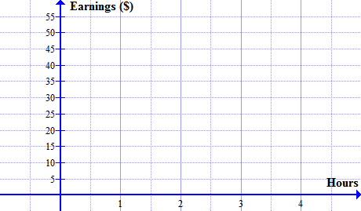a) Complete this table of values showing Bort’s total earnings for up to 4 hours serving.

|  |  |
| --- | --- |
| $$Time(hours)$$ | $$Sam^{'}s Earnings (\$)$$ |
| 0 | 25 |
| 1 |  |
| 2 |  |
| 3 |  |
| 4 |  |

b) Graph Bort’s earnings, and draw the line!   
  
c) If “y” represents Bort’s earnings, and “x” represents the number of hours he worked, state an equation for the graph you made.

Equation: y = _____ x _______

8. The graph below and to the left represents the amount of money in a student’s bank account over a period of 5 weeks. Answer the following questions based on the graph.

|  |  |  |
| --- | --- | --- |
|  |  | a) State a rule for this graph in words:  Balance starts at _____________ and ______________(increases/decreases) by ________________per week (rate). b) Create an Algebraic Rule (Equation) for the bank balance (y) after *x* weeks:  y = _____ x _______  c) Calculate the amount of money in the account after 25 weeks. |

9.Phil was using algebra to solve the following problem: “Find the equation of the line with a slope of 4, through the point (-2, 3)”. His attempted solution is given below:

$$y=mx+b \\ y=4x+b \\ -2=4\left(3\right)+b \\ -2=12+b \\ -2-12=b \\ -14=b \\ ∴Equation is given by: y= -14x+4$$

Phil made **two mistakes** determining the equation of his line. Circle them and explain (in point form) what he did wrong.

10. **Use algebra** to find the equations of the following lines. A graph has been given if you wish to use it.

|  |  |  |  |
| --- | --- | --- | --- |
| a) Find the equation of the line with a slope of -1, through the point (6, 2) | | | |
| Identify the slope, and your point: | | | Sketch: |
| $$m=$$ | $$x=$$ | $$y=$$ |
| Put in your slope: $$y=_____x+b$$ | | |
| Put in your point and solve for “b” | | |
| Equation: $y=$_____x ______ | | |

|  |  |  |  |
| --- | --- | --- | --- |
| b) Find the equation of the line with a slope of $\frac{2}{3}$, through the point (9, 7) | | | |
| Identify the slope, and your point: | | | Sketch: |
| $$m=$$ | $$x=$$ | $$y=$$ |
| Put in your slope: $$y=_____x+b$$ | | |
| Put in your point and solve for “b” | | |
| Equation: _____x ______ | | |

11. Elisa was very confident about her chances to win the school election when voting began this morning. As voter information begins to trickle in, she starts losing her cool and becomes less confident. After 3 hours, she is 79% sure that she is going to win. After 7 hours, she is only 51% sure she is going to win.



a) Use the slope formula to determine the slope between these two points. What does the slope mean in this particular question?

b) Use algebra to determine the y-intercept of the line joining these two points. What does the y-intercept mean in this particular question?

|  |  |  |
| --- | --- | --- |
| $$m=$$ | $$x=$$ | $$y=$$ |
| Put in your slope:  *y = _____x + b* | | |
| Put in your point and solve for “b” | | |
| Equation: $y=$_____x ______ | | |

c) How confident is Elisa 12 hours after voting starts?

d) Does Elisa have any confidence left after 15 hours?