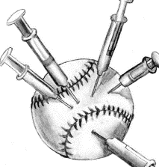
1) History would suggest that 2% of professional baseball players use PED’s (Performance Enhancing Drugs). A new test will catch a PED user 95% of the time. However, the test will also give a false positive 5% of the time.
a) Draw a tree diagram of the possible outcomes of a drug test (Using/Not Using and +/-), and then calculate the probabilities for the following cases (as a decimal, and as a fraction out of 10,000).
Tree Diagram:

Outcome | Probability Calculation (Decimals) | Probability (%) | Probability (out of 10,000)
Using and +
Not Using and +
Totals
b) Fill in the following table that calculates the probability that a player would test positive.

c) What is the probability that a player who tested positive for PEDs is actually taking them?

BONUS) The Dragons are taking on the Puppies in a 4 game baseball exhibition series where they play all 4 games no matter what!
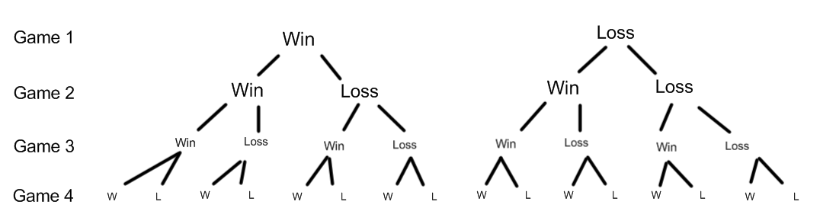
To keep things simple… in every game, they have a 50% chance of winning, and a 50% chance of losing.

Mr. Smith has listed all of the outcomes where they win the series (3 or 4 wins). Find the probability of each outcome.
Outcome | Probability Calculation (Decimals) | Probability (%)
WWWW
WLWW
WWLW
WWWL
LWWW
Totals

Conclusion: What is the probability of the Dragons winning this exhibition series?

