1) [20 marks] a) Consider this new Galton board. In our preparation day, you calculated the probabilities of landing in each bin. Copy your results onto this page, or do the problem if you haven’t already.
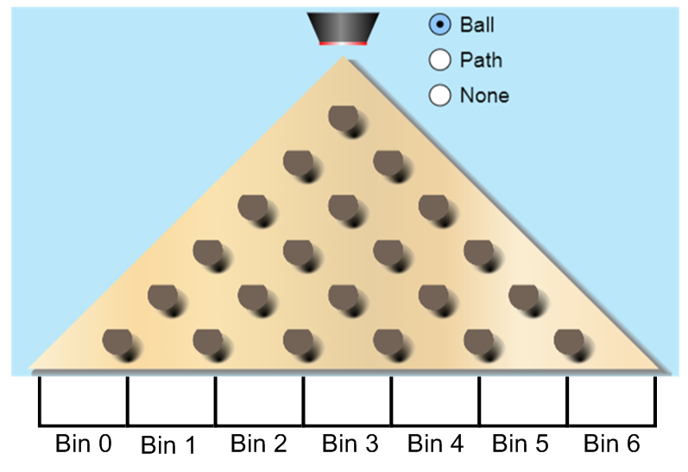
Bin Number | 0 | 1 | 2 | 3 | 4 | 5 | 6
Probability (Fraction)
Probability (Decimal, 3 places)

b) In 1,000 drops of a ball, how many times would you expect a ball to land in bin number 2?

c) If two people dropped 1,000 balls into the board, would they get the same number of balls in bin number 2? Why or why not?

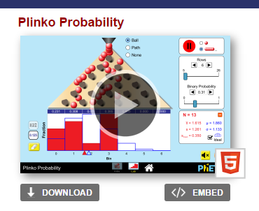
2) Go to the following website: https://phet.colorado.edu/en/simulation/plinko-probability
You should get a screen that sort of looks like this:
Hit the play button, select “INTRO” and then play around with it for a bit.
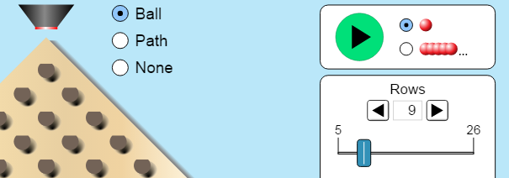
3) When you are ready to begin your analysis, select “LAB”. Set the number of rows to 6 so that you have 7 bins (0, 1, 2, 3, 4, 5, 6). It should match your diagram on the previous page.
At the bottom left of your screen, select the “0.125” option as it will calculate decimal probabilities for you.
4) Drop 10 balls into the board. Record the probability of landing in each bin.
Bin # | 0 | 1 | 2 | 3 | 4 | 5 | 6
Probability (Decimal, 3 places)

5) Drop 100 balls into the board. Record the probability of landing in each bin.
Bin # | 0 | 1 | 2 | 3 | 4 | 5 | 6
Probability (Decimal, 3 places)

6) Drop 500 balls into the board. Record the probability of landing in each bin.
Bin # | 0 | 1 | 2 | 3 | 4 | 5 | 6
Probability (Decimal, 3 places)

6) Drop 1,000 balls into the board. Record the probability of landing in each bin.
Bin # | 0 | 1 | 2 | 3 | 4 | 5 | 6
Probability (Decimal, 3 places)

7) Which of the experimental probability tables above (3 through 6) matched the theoretical probability table the closest?

8) If you and your friend each dropped 1,000 balls in this simulation, describe how you would expect your results to compare.
9) [10 marks] The Dragons and the Wyverns are playing a 5 game playoff series. The Dragons are a superior team, and win a certain % of the time. What are is the probability that the Dragons win the series?
Mr. Smith will give you your winning percentage: _______________
Mr. Smith has listed all of the outcomes where they win the series (3, 4, or 5 wins). Find the probability of each outcome. Note, in a best of 5 series, when a team wins 3 games, the series is over.
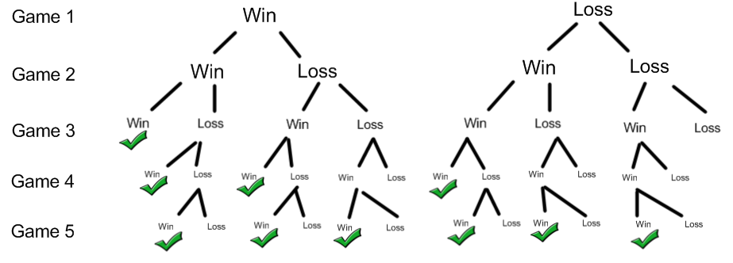
Outcome | Probability Calculation (Decimals) | Probability (%)
WWW
WLWW
WWLW
WWWL
WWLLW
WLWLW
WLLWW
LLWWW
LWLWW
LWWLW
Totals

Conclusion: What is the probability of the Dragons winning this playoff series?

