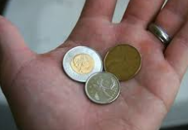
We all know that the probability of flipping tails (or heads) on a coin is 50%. But what if we flip 3 coins? What is the probability that they all come up tails? In this assignment, you will conduct a probability experiment, and as a class we will see if we can determine this probability.
/10

Instructions: The task is simple. Flip 3 coins (all at the same time) and write down how many tails turn up. Each student will do this 30 times each.

Record your results in the following table:

Trial # | # of Tails  (0, 1, 2 or 3) | Trial # | # of Tails  (0, 1, 2 or 3) | Trial # | # of Tails  (0, 1, 2 or 3)
1 |  | 11 |  | 21
2 |  | 12 |  | 22
3 |  | 13 |  | 23
4 |  | 14 |  | 24
5 |  | 15 |  | 25
6 |  | 16
7 |  | 17
8 |  | 18
9 |  | 19
10 |  | 20

Summary: Count up in your table how often each occurred, and record it below. Make sure the total is 25.

Event | Frequency (Number of times event occurs)
0 tails
1 tail
2 tails
3 tails
Total
Based on your results, state the experimental probabilities of each total in the table below as a fraction, decimal and percentage. Make sure your totals add to 25/25, 1, and 100%.

Event | Fraction | Decimal (Divide) | Percentage (x 100)
0 tails
1 tail
2 tails
3 tails
Totals

Create a graph showing how often each was rolled. To do this, simply create 4 bars, one for each possible number of tails. The height of the bar is determined by how many times you got that number of tails. An example has been given in the top right.

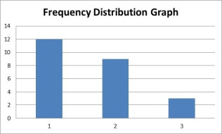

Tomorrow, we will pool all of our totals together to get an even better idea of what the theoretical probabilities should be.

