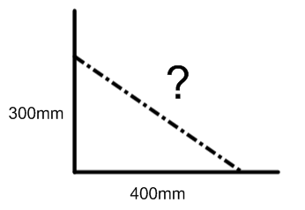
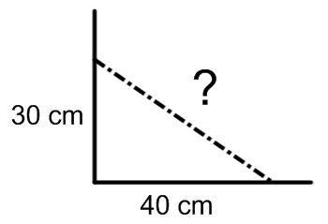
1) Recall that any 3-4-5 triangle forms a right angle. Given the following measurements, determine the length of the diagonal that would make the cuts square. each.
/22

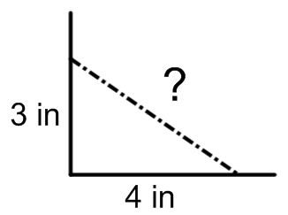
a) b) c)

Diagonal = ____________ Diagonal = ____________ Diagonal = ____________
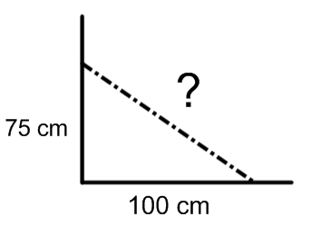
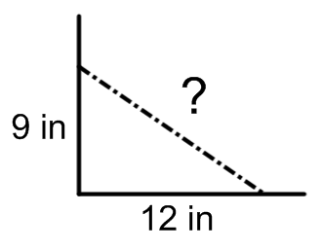
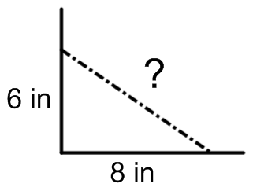
d) e) f)

Diagonal = ____________ Diagonal = ____________ Diagonal = ____________

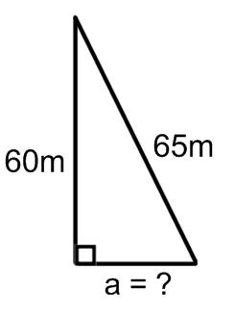
2) Determine the length of the hypotenuse in triangle a), and the leg in triangle b). each.
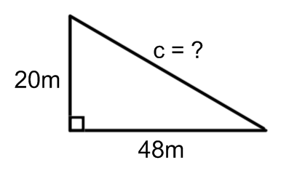
a) b)
$$a^{2}=c^{2}-b^{2}$$

$$c^{2}=a^{2}+b^{2}$$

3) The roof truss drawn below is a type of “scissors” truss. The truss is comprised of some right angle triangles, with 1 foot of overhang on each side.
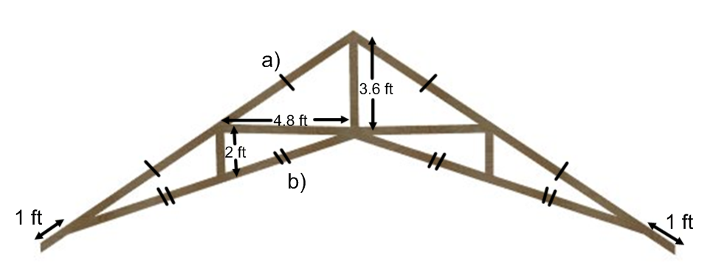

a) Determine the length of the hypotenuse in the upper right-angle triangle.
b) Determine the length of the hypotenuse in the lower right-angle triangle.

c) Many of the lengths in the truss are identical (shown by single or double ticks). Add up every single piece of wood to determine how much lumber (roughly) is required for one of these trusses.

Conclusion: In order to make one of these trusses, _____________ feet of lumber is needed.

