Today we are going to review the following topics:
- Finding the slope between two points using the slope formula
- The relationship between the slopes of perpendicular lines
- Finding the equation of a line algebraically
The Slope of a Line Segment Formula
Visual: Formula Derivation:

You try it: Find the slope of the line segment joining the following pairs of points. Simplify as much as possible.
a) $\left(2, 3\right)$ and $(17, 8)$ b) $\left(-2, 8\right)$ and $(4, -2)$ c) $\left(-5, 0.5\right)$ and $(2.5, 0)$

Parallel and Perpendicular Slopes
Recall that parallel lines have……
While the slopes of perpendicular lines are…..
Complete the following table to reinforce these ideas:
Equation of Line | Slope of Line | Slope of a Parallel Line | Slope of a Perpendicular Line
$$y=\frac{2}{3}x+5$$
$$y=-2x+12$$
$$y=7$$
Finding the Equation of a Line Algebraically
We will be doing a lot of work with lines over the next few weeks. An important skill for us to have will be to take some general information about a line, and determine its exact equation. For the following examples, we will draw a visual of each situation. In practice, you can always make a rough sketch if you need to visualize a problem.
We will always use the same strategy:
- Determine the slope of the desired line (if not given)
- Use the slope and a point to find the y-intercept of the desired line
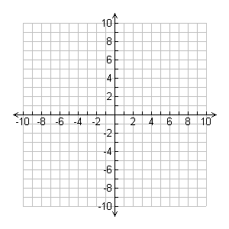
Example 1: Find the equation of the line with a slope of $1/3$, through the point $\left(6, 1\right).$
Solution: | Visual:

Example 2: Find the equation of the line that is parallel to $2x+3y=-9$ through the point $\left(5, -3\right).$
Solution: | Visual:

Example 3: Find the equation of the line that passes through the points $A(-6, -7)$ and $B(9, 3)$
Solution: | Visual:

Example 4: Find the equation of the line through $(1, 1)$ that is perpendicular to $x-4y=7$.
Solution: | Visual:

