Note: For the following three problems, you may use any method you’d like to get the surface area. You do not need to use the table, or draw a net, but you may if you wish.

/25

1) Find the surface area of this rectangular prism. ➄

|  |  |  |  |
| --- | --- | --- | --- |
| Method 1: Use a net and a table | | | |
| Shape: | | Net: | |
| Basic Shape #1 | Basic Shape #2 | | Basic Shape #3 |
|  |  | |  |
| Area = | Area = | | Area = |
| Total Area (2 of each rectangle) = | | | |

Method 2: Use the formula

2) Find the surface area of this triangular prism. Hint: the triangle is isosceles, so two of the rectangles will be the same. ➄

|  |  |  |  |
| --- | --- | --- | --- |
| Method 1: Use a net and a table | | | |
| Shape: | | Net: | |
| Basic Shape #1 | Basic Shape #2 | | Basic Shape #3 |
|  |  | |  |
| Area = | Area = | | Area = |
| Total Area (2 of each triangle, and 3 rectangular sides) = | | | |

Method 2: Use the formula

3) Find the surface area of this cylinder ➄

|  |  |
| --- | --- |
| Method 1: Use a net and a table | |
| Shape: | Net: |
| Basic Shape #1 | Basic Shape #2 |
|  |  |
| Area = | Area = |
| Total Area (2 circles and the rectangle) | |

Method 2: Use the formula $SA=2×π×r^{2}+2×π×r×h$

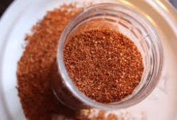**Minimizing the Surface Area of a Rectangular Prism [10 marks]**

Bort is selling his own brand of barbecue dry rub out of his garage. He his selling his product in packages of 1000 cm3 (1000 mL). However, Bort is unsure how to design his package to minimize the material needed (and hence the cost).

In this investigation, you will find the volume and surface area of 6 rectangular prisms. Afterwards, you should be able to make a recommendation to Bort!

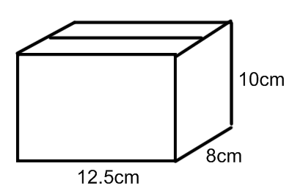i) Find the volume and surface area of the following prisms. They are not drawn to scale!

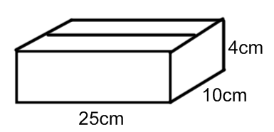a) b)

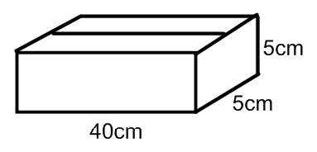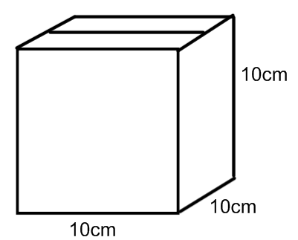c) d)

ii) Use all of your calculations to complete the following table:

|  |  |  |
| --- | --- | --- |
| Dimensions of Box (cm) | Surface Area (cm2) | Volume (cm3) |
| 25 x 10 x 4 |  |  |
| 12.5 x 10 x 8 |  |  |
| 10 x 10 x 10 |  |  |
| 40 x 5 x 5 |  |  |

iii) Conclusion: Which of the 4 options will be the cheapest for Bort to make? What kind of special 3D shape is this?

Bonus: What is the volume and surface area of the following composite 3D shape?