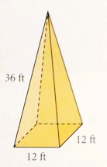
1) Find the surface area of the following square based pyramids. In each case, the slant height is given. each.
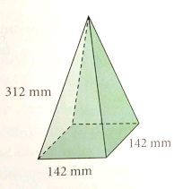
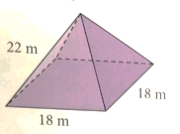
a) b) c)

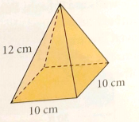
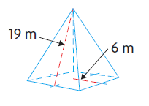
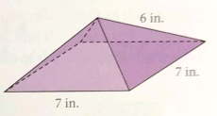
d) e) f)

2) For the following square-based pyramids, determine the slant height first, and then calculate the surface area.
a) Pyramid: Find the slant height: Find the surface area:
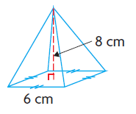

b) Pyramid: Find the slant height: Find the surface area:
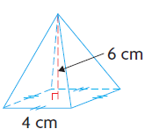

c) Pyramid: Find the slant height: Find the surface area:
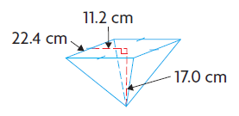

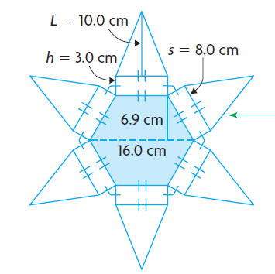
3) [10 marks] Mr. Smith found an old jewelry box in his basement. The box is a hexagonal prism on the bottom, with a hexagonal pyramid on top. The box dimensions and a net are given below. Mr. Smith wants to paint it, so he needs to know the surface area.
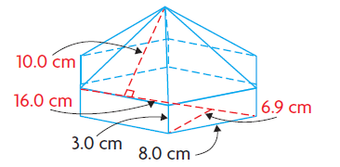

Use the following table to find the surface area of the jewelry box.
Basic Shape #1 (rectangle) | Basic Shape #2 (triangle) | Basic Shape #3 (trapezoid)
Rough work: | Rough work: | Rough work:
Area = | Area = | Area =
Total Area (6 triangles, 6 rectangles, and 2 trapezoids):

