In this investigation/review you will graph different quadratic relations and compare them to what we will refer to as the “Basic Parabola”.

TECHNOLOGY OPTION
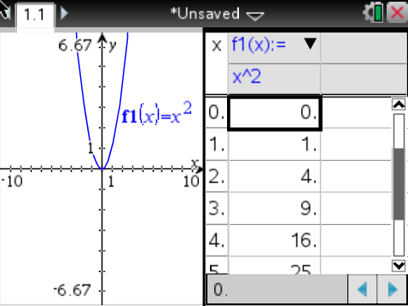
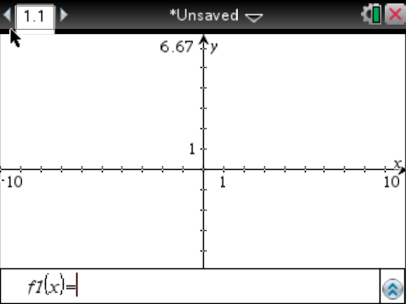
If you are using a TI-nspire, add a new “Graph Document” and enter your relation. You can bring up a table of values by pressing “ctrl” then “T”.

THE BASIC PARABOLA
Relation | y = x²
Table of Values
x | y
-3
-2
-1
0
1
2
3
Fill in the following information about the parabola:
Vertex: |  | What is the “step pattern” of the parabola? (how do you move from point to point, starting from the vertex?) | Over 1
 |  |  | Over 1
 |  |  | Over 1

Since all parabolas have their “over” steps the same, we usually refer to these three numbers as the Step Pattern of the parabola. So, the Step Pattern of this parabola is

______, ______, _____

Relation #1: y = x² + 2
Table of Values
x | y
-3
-2
-1
0
1
2
3
Fill in the following information about the parabola:
What is the vertex? _________ |  | What’s the Step Pattern? | Over 1
 |  |  | Over 1
 |  |  | Over 1

Relation #2: y = x² - 1
Table of Values
x | y
-3
-2
-1
0
1
2
3
Fill in the following information about the parabola:
What is the vertex? _________ |  | What’s the Step Pattern? | Over 1
 |  |  | Over 1
 |  |  | Over 1
What is the effect of adding or subtracting a number after the “x²”?

Relation #3: y = (x – 5)²
Table of Values
x | y
2
3
4
5
6
7
8
Fill in the following information about the parabola:
What is the vertex? _________ |  | What’s the Step Pattern? | Over 1
 |  |  | Over 1
 |  |  | Over 1

Relation #4: y = (x + 3)²
Table of Values
x | y
-6
-5
-4
-3
-2
-1
0
Fill in the following information about the parabola:
What is the vertex? _________ |  | What’s the Step Pattern? | Over 1
 |  |  | Over 1
 |  |  | Over 1
What is the effect of adding or subtracting a number after the “x” in the brackets?
Relation #5: y = 3x²
Table of Values
x | y
-3
-2
-1
0
1
2
3
Fill in the following information about the parabola:
What is the vertex? _________ |  | What’s the Step Pattern? | Over 1
 |  |  | Over 1
 |  |  | Over 1

Relation #6: y = -2x²
Table of Values
x | y
-3
-2
-1
0
1
2
3
Fill in the following information about the parabola:
What is the vertex? _________ |  | What’s the Step Pattern? | Over 1
 |  |  | Over 1
 |  |  | Over 1
What is the effect of multiplying a positive or negative number by the “x²”?

