1) Solve each equation. You can solve by inspection, or use opposite operations.
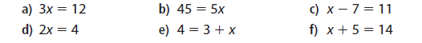

2) Write an equation for each of the represented balanced scales. You do not have to solve the resulting equation.
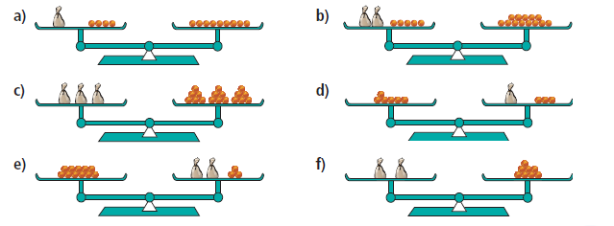

3) Solve the following equations:
a) $3x+2=17$ b) $2x-5=1$ c) $33=4x+5$

d) $7x+1=22$ e) $2=6x-10$ f) $5x-2=38$

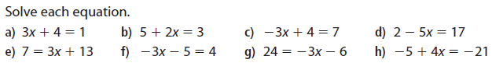
4) Use the space below for the following questions. Do as many as you can!

5) Check any 3 of your answers from question 4). You can just use your calculator!
