Consider the following wheel from the game show “Wheel of Fortune”. We will be investigating what a contestant can expect to make by spinning the wheel one time.
/10
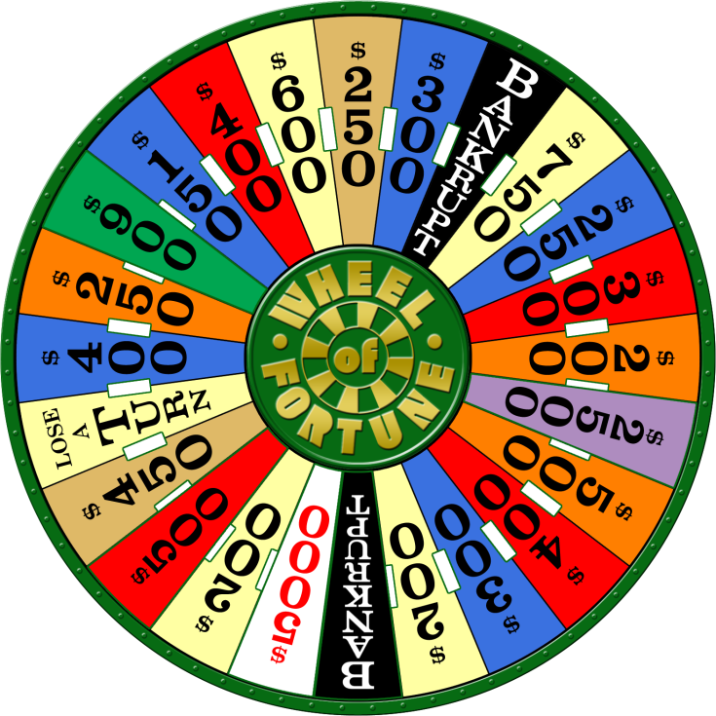
1) Calculate the probability of EACH option as a fraction, and as a percentage. You can treat the “Lose A Turn” and “Bankrupt” as winning 0$. Make sure your totals add up! Mr. Smith has done one section for you. Keep the same accuracy as Mr. Smith.
Section | Probability as a Fraction | Probability as a Decimal (Divide) | Probability as a Percent (x 100)
0$
$150
$200
$250
$300
$400
$450
$500
$600
$750
$900 | $$1/{24}$$ | 0.0417 | 4.17%
$2,500
$5,000
Totals
2) An interesting thing we can do with these values is calculate the “average” value of one spin on the wheel we will be using the decimal probabilities you calculated earlier.
Section | Probability as a Decimal | Multiply the “$” value by the decimal probability
0$
$150
$200
$250
$300
$400
$450
$500
$600
$750
$900 | 0.0417 | $37.53
$2,500
$5,000
Totals

This value you get by multiplying the probabilities by the outcome value is called the expected value. You’ve just calculated what a player can make by making one spin!

