- Find the volume of the following solids.
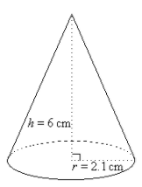
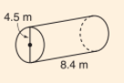
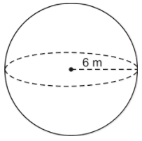
a) b) c)

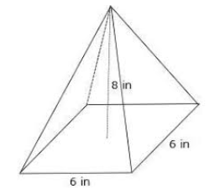
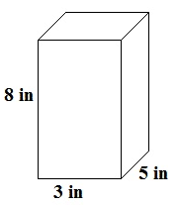
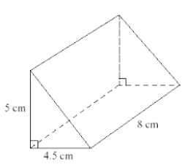
d) e) f)

- Find the surface area of the following solids.

a) b) Note: 4.5m is the radius here

3) Find the volume of the following 3D shapes.

Solid #1 | Basic Shape 1 | Basic Shape 2
Sketch: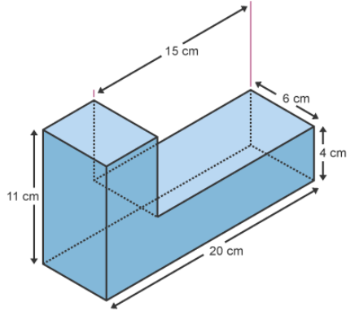
 | Volume = | Volume =
Total Volume =
4) Bort is taking a glass blowing course, and is designing two glasses. Find the volume of each glass.

Glass 1: Cylinder

Glass 2: Cylinder and Half a Sphere | Basic Shape 1 | Basic Shape 2
Sketch:
 | Volume = | Volume =
Total Volume =

5) The dimensions of an irregularly shaped pool are shown in the diagram below.

a) Find the area of the pool surface:

Diagram of Pool Surface
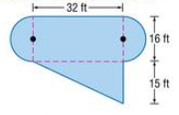
Basic Shape #1 | Basic Shape #2 | Basic Shape #3
Area = | Area =
Total Area =

b) The pool is 6 feet deep. Use the formula: $V_{prism}=Area of Base ×Height of Prism$ to find the volume of the entire pool.

c) Your backyard hose can pump out 1.2 feet³ of water every minute. How many minutes will it take to fill your pool?

