1) Find the midpoint of the following line segments: each.
/36
a) $A\left(1.2, -3.4\right)$ and $B(-9.1, -7.3)$. b) $C\left(102, 12\right)$ and $D(-48, 216)$.

2) Find the length of the following line segments to two decimal places: each.
a) $A\left(1.2, -3.4\right)$ and $B(-9.1, -7.3)$. b) $C\left(102, 12\right)$ and $D(-48, 216)$.

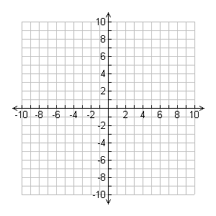
3) Consider the triangle formed by the following three points: $A\left(-7, -2\right), B\left(1, 5\right), and C(5, -7)$.
a) Draw the median from vertex A
b) Draw the right bisector of side BC
Space for midpoint/slope calculations:

4) [6 marks] Recall an old investigation where found the circumcentre of the triangle formed by the points:
A(1, -5), B(7, 1), and C(-5, 7).
We found the circumcentre (where the 3 right bisectors met) to be at D(0, 2). In this question you will prove that the circumcentre (0, 2) is equidistant from all 3 corners of the triangle.
In the space below calculate the exact distance of the following 3 line segments: AD, BD, and CD
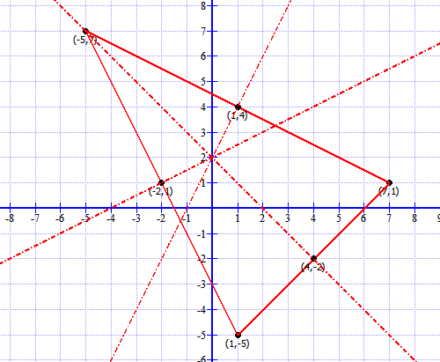
a) Length of AD

b) Length of BD c) Length of CD

Were all 3 lengths the same? If so, you have proven that the circumcentre is equidistant from the 3 corners of the triangle. Cool!

5) Consider the triangle formed by the points D(-3, 8), E(9, 2), and F(3, -4).
a) Draw all 3 medians of this triangle.

b) Determine the centroid of this triangle using the formula:
$$Centroid=\left(\frac{x_{1}+x_{2}+x_{3}}{3},\frac{y_{1}+y_{2}+y_{3}}{3}\right)$$

5) Find the circumcenter of the triangle formed by the points A(0, 0), B(2, 6), and C(8,0). Use the prompts that Mr. Smith gives you, and always refer to your diagram to check answers! Use extra paper if you feel you need more space to work.
a) Find the equation of the right bisector of AB.

b) Find the equation of the right bisector of BC

c) Find the intersection point of your lines you found in a) and b). This is the circumentre!

