In this first task you will find the area of a Hipped Roof, and a Mansard Roof. To start, we will make sure you can apply the new formula for a trapezoid:
$$A_{trap}=(a+b)×h÷2$$
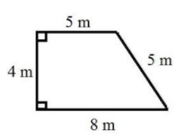
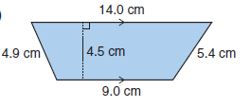
1) Find the areas of these two trapezoids: each.
a) b)

2) Find the area of this “Mansard Roof” by using the table set up by Mr. Smith:
Visual of Roof:
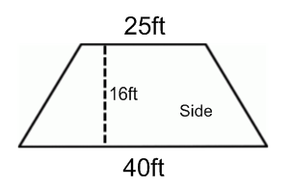
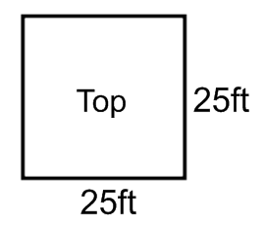
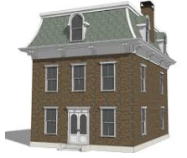
Area of Rectangle Portion (calculations) | Area of Trapezoid Portion (calculations)
Area = | Area =
Total Area (top + 4 trapezoids)=
3) Find the area of this “Hipped Roof” using the provided table.
Visual of Roof:
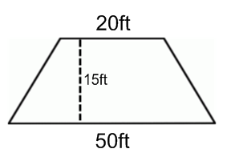
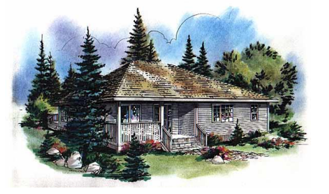
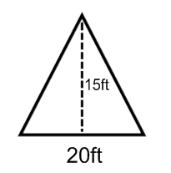
Area of Triangle Portion (calculations) | Area of Trapezoid Portion (calculations)
Area = | Area =
Total Area (2 triangles + 2 trapezoids) =

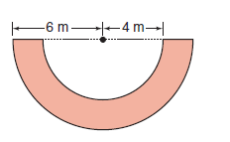
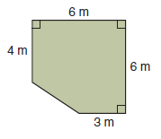
4) Calculate the area of these two irregular shapes. each.
a) b)

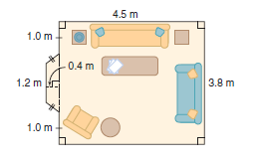
5) You decide to put up carpet down in your living room. A diagram of your living room is given at the right.
Determine the area of your
living room.

BONUS:
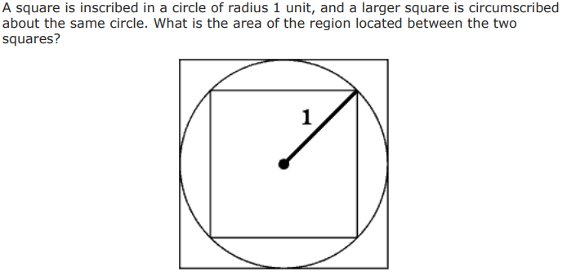
Hint: Use the Pythagorean Theorem to find the dimensions of the small square!

