Find the area of the following floor layouts/shapes. Mr. Smith has given you some structure for the first 3.

Layout #1
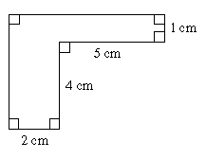
Basic Shape #1 | Basic Shape #2
Area = | Area =
Total Area =

Layout #2
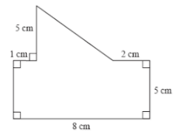
Basic Shape #1 | Basic Shape #2
Area = | Area =
Total Area =

Layout #3
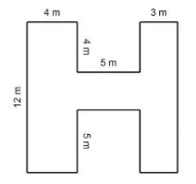
Basic Shape #1 | Basic Shape #2 | Basic Shape #3
Area = | Area = | Area =
Total Area =

Without any structure from Mr. Smith, can you find the area of this shape?

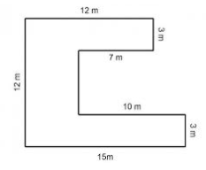

Answers: 1. 15 cm² 2. 52.5 cm² 3. 99 m² 4. 111 m²

