1) Solve the following linear systems using elimination. In these questions, Mr. Smith has laid out a clear structure for you to use. In later questions, you will create this structure on your own. each.
/40

Linear System:  $3x-y=11$  $2x+y=14$ | Add or Subtract?
Do the Addition/Subtraction: | Sub into equation or
Solution: ( , )

Linear System:  $2x+3y=5$  $2x+y=3$ | Add or Subtract?
Do the Addition/Subtraction: | Sub into equation or
Solution: ( , )

Linear System:  $3x+4y=10$  $2x+4y=8$ | Add or Subtract?
Do the Addition/Subtraction: | Sub into equation or
Solution: ( , )

Linear System:  $0.5x-0.2y=2.3$  $1.5x+0.2y=7.7$ | Add or Subtract?
Do the Addition/Subtraction: | Sub into equation or
Solution: ( , )

3) Solve the following linear systems using elimination. For each one, decide if you are going to add or subtract… then do it!! Mr. Smith will take your best 2. each.

a) b) $3x+7y=16$ $5x-5y=25$
$3x+5y=14$ $2x+5y=3$

Add or Subtract? Add or Subtract?

Solution: ( , ) Solution: ( , )

c) d) 8$x-3y=32$ $5x+2y=12$
$5x+3y=20$ $3x+2y=4$

Add or Subtract? Add or Subtract?

Solution: ( , ) Solution: ( , )

4) At a hockey game, two of your friends come back with some food:
- Asher has 3 hotdogs, and 2 orders of deep fried pickles. It cost him $19.75.
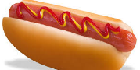
- Bryden has 1 hotdog, and 2 order of deep fried pickles. It cost him $11.25.
$$3d+2p=19.75$$
$$d+2p=11.25$$

What is the price of one hotdog? What is the price of one order of deep fried pickles?

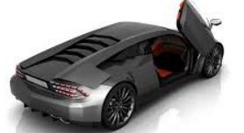
5) At a fundraising car wash, it costs more to wash a van than a car.
- In the morning, 10 cars and 15 vans were washed. They made $325.
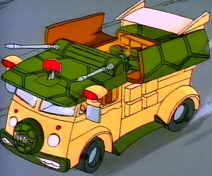
- In the afternoon, 12 cars and 15 vans were washed. They made $345.
$$10c+15v=325$$
$$12c+15v=345$$

How much does it cost to wash a car? To wash a van?

