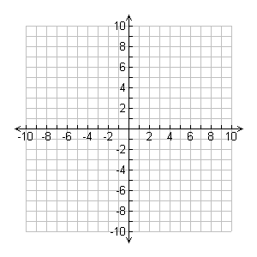
1) Find the equation of the line with a slope of $-3/4$, through the point $\left(8, 1\right).$
Solution: | Visual:

Example 2: Find the equation of the line that is perpendicular to $4x-3y=-9$ through the point $\left(4, 4\right).$
Solution: | Visual:

3) Find the equation of the line that passes through the points $A(5, -7)$ and $B(1,3)$
Solution: | Visual:

4) Find the equation of the line with the same y-intercept as $2x+5y=10$ that is also perpendicular to $7x-9y=5$.
Solution: | Visual:

