1) Graph the following lines by plotting the y-intercept, then using the slope to get more points, then using a ruler to finish drawing the line. each.
/36

a) $y=\frac{1}{5}x+4$ | b) $y=3x-5$
Slope (m) = | Slope (m) =
y-int (b) = | y-int (b) =
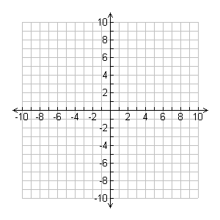
c) $y=-\frac{1}{3}x+4$ | d) $y=x-8$
Slope (m) = | Slope (m) =
y-int (b) = | y-int (b) =
e) $y=6$ | b) $y=2x$
Slope (m) = | Slope (m) =
y-int (b) = | y-int (b) =
c) $y=-\frac{4}{3}x+1$ | d) $y=-5x+9$
Slope (m) = | Slope (m) =
y-int (b) = | y-int (b) =

2) Mr. Smith has graphed a line for you. You need to figure out the slope of the line, the y-intercept of the line, and then from there write out the equation in $y=mx+b$ form. each.

a) | b)
Slope (m) = | Slope (m) =
y-int (b) = | y-int (b) =
Equation: $y=$ | Equation: $y=$
c) | d)
Slope (m) = | Slope (m) =
y-int (b) = | y-int (b) =
Equation: $y=$ | Equation: $y=$

