1) Find the solution of the following linear systems. Remember that you will need to determine the slope and y-intercept of each line first. each.
/48 or Level:

a) $y=\frac{1}{2}x-4$ b) $y=2x-7$
$y=-\frac{1}{2}x+4$ $y=x-3$

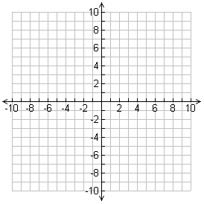
Sketch: Sketch:

Point of Intersection: Point of Intersection:

c) $y=\frac{1}{5}x-2$ d) $y=\frac{3}{4}x+5$
$y=x-10$ $y=-\frac{1}{2}x-5$

Sketch: Sketch:

Point of Intersection: Point of Intersection:
2) Solve the following linear systems using algebra. Mr. Smith has provided a table for you for the first few.

a) $y=5x+5$
$y=7x+3$
1) Set the equations equal, and solve for “x” | 2) Sub your value for “x” into either equation
Point of Intersection = ( , )

b) $y=15x+19$
$y=9x+25$
1) Set the equations equal, and solve for “x” | 2) Sub your value for “x” into either equation
Point of Intersection = ( , )

c) $y=3.5x-2$
$y=1.5x+2$
1) Set the equations equal, and solve for “x” | 2) Sub your value for “x” into either equation
Point of Intersection = ( , )

d) $y=-5x+2$
$y=4x+47$
1) Set the equations equal, and solve for “x” | 2) Sub your value for “x” into either equation
Point of Intersection = ( , )

e) $y=0.2x+1.4$
$y=0.5x+0.5$
1) Set the equations equal, and solve for “x” | 2) Sub your value for “x” into either equation
Point of Intersection = ( , )
3) Solve the following linear systems. Mr. Smith has not given you the structure for these.

f) $y=\frac{1}{2}x-2$
$y=x-7$

g) $y=\frac{3}{4}x+1$
$y=\frac{1}{4}x+5$

Point of Intersection = ( , ) Point of Intersection = ( , )

h) $y=1.2x+3$
$y=0.5x+10$

i) $y=0.32x+0.45$
$y=0.24x+0.85$

Point of Intersection = ( , ) Point of Intersection = ( , )

