In the following task, you will find the volume (in cm³) of the following everyday objects, and compare them to the stated capacity (in mL). Remember that these two units of measurement are equal!
1) A Monster Energy Drink can (capacity of 500mL). The can has a radius of 6.62 cm and a height of 16.8cm.
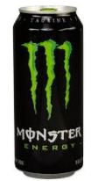

2) A carton of milk (capacity 1000mL). The carton is 7.5cm by 7.5cm by 16.5 cm.
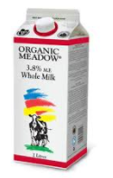

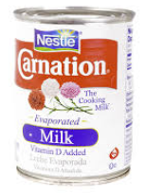
3) A can of evaporated milk (capacity 354mL). The can has a radius of 8cm and a height of 11cm.

4) A Toblerone Bar (100g of chocolate which translates to about 94mL of chocolate). The length of the bar is 20.8cm. The base is a triangle with a base length of 3.5cm, and a height of 3cm.
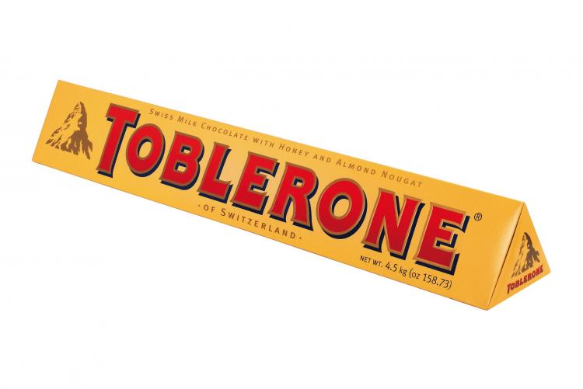

Discussion: Why might there be differences in the stated volume on the package, and the volumes you calculated?

Level R | Level 1 | Level 2 | Level 3 | Level 4
Task is incomplete. Work is very unorganized and hard to follow. Mr. Smith may ask you to redo it. | Calculations have major errors. Work is somewhat organized. Instructions were not followed. | Calculations have minor errors. Work is somewhat organized. Instructions were followed for the most part. | Calculations have minor errors. Work is organized. Instructions were properly followed. | All calculations are correct. Work is well organized. Instructions were followed meticulously.

