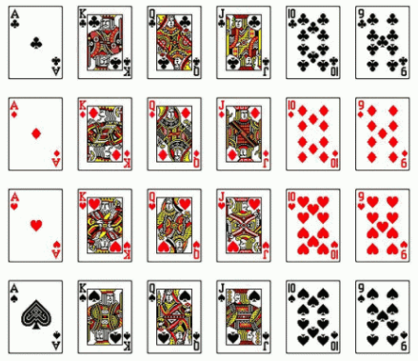
1) Consider the following deck used in playing euchre. It only uses 24 cards.

a) Complete the given table of probabilities if one card is chosen at random. Probabilities can be expressed as a fraction, decimal, or percentage.

What is the Probability of…. | Fraction | Decimal | Percent
Drawing the 9 of hearts?
Drawing a club?
Drawing a card with a number
Drawing a Face Card

2) Determine whether each probability is subjective (S), experimental (E), or theoretical (T).
(a) The probability of rolling a two on a single dice is $1/6$ _______
(b) In 100 flips of a coin, tails came up 52 times. The probability of flipping tails is 52% _______
(c) The probability of flipping tails on a single coin is $1/2$. ______
(d) A MEL4E student estimates they have a 95% chance of getting an A on their test. _______

2) Consider this new Galton board, with one extra slot. Like we did in our note, calculate the theoretical probability of landing in each spot on the following Galton Board.
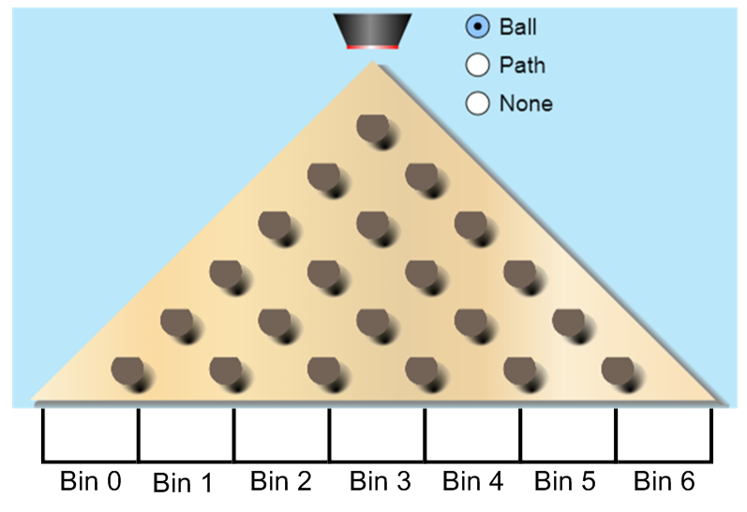
Bin Number | 0 | 1 | 2 | 3 | 4 | 5 | 6
Probability (Fraction)
Probability (Decimal)

Next day, you will run some simulations based on these probabilities.

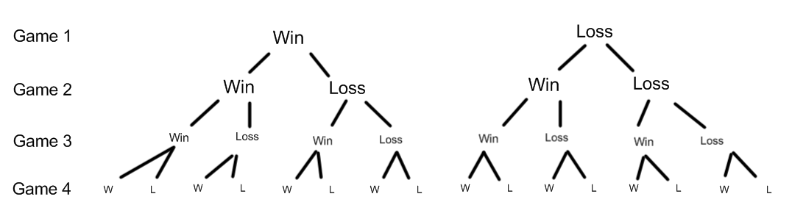
3) The Dragons and the Wyverns are playing a 5 game playoff series. The Dragons are a superior team, and win 70% of the time. What are is the probability that the Dragons win the series? Is it 70%? More than that? Less than that?
Mr. Smith has listed all of the outcomes where they win the series (3 or 4 wins). Find the probability of each outcome.
Outcome | Probability Calculation (Decimals) | Probability (%)
WWWW
WLWW
WWLW
WWWL
LWWW
Totals

Conclusion: What is the probability of the Dragons winning this exhibition series?

