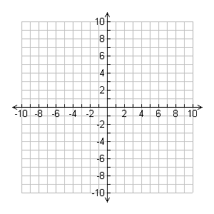1) [5 marks] Consider the relation: $y=x^{2}+4x-5$

/33

a) Find the x-intercepts by using the quadratic formula:

b) Make a sketch of this relation. Use the x-intercepts, axis of symmetry, and vertex.

2) Find the x-intercepts for the following quadratic relations using the quadratic formula. Where appropriate, round your final answer to 2 decimal places. ➁ each.

a) y = 6x2 + 11x + 3

b) y = 2x2 + 12x – 14 c) y = 4x2 + 10x + 1

3) [5 marks] The sum of the squares of 3 consecutive positive numbers is 434. Determine the 3 numbers by setting up a quadratic equation.

4) [7 marks] A diver bounces off a 3-m springboard at an initial upward speed of 4 m/s. A graph of the divers height over time is provided to help you check your answers to the following:



a) Create a quadratic model for the height of the diver above the water.

b) After how many seconds does the diver enter the water? Round to the nearest hundredth of a second.

c) Over what time interval is the height of the diver greater than 3.5 m above the water? Round to the nearest hundredth of a second.

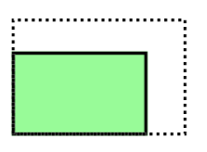5) [5 marks] A rectangular garden measures 5 m by 7 m. Both dimensions are to be extended by the same amount so that the area of the garden is doubled. By how much should the dimensions increase, to the nearest tenth of a metre?

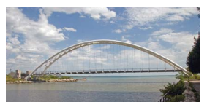6) [5 marks] The shape of the Humber River pedestrian bridge in Toronto can be modelled by the equation $y=-0.0044x^{2}+21$. All measurements are in metres. Determine the maximum height the bridge reaches above the ground, to the nearest tenth of a metre.