Whatever you don’t finish in class today will need to be finished on your own time, so get to work!
./52

1) Identify all the key parts of the following parabolas: each.

a)
Vertex
x-intercepts
y-intercept
Axis of Symmetry
Direction of Opening
Max or Min Value

b)
Vertex
x-intercepts
y-intercept
Axis of Symmetry
Direction of Opening
Max or Min Value

2) Try and make a sketch of the following parabolas given the equation in vertex form: each.

a) $y={(x+6)}^{2}-5$ b) $y=2{(x-2)}^{2}-6$

Vertex: Vertex:
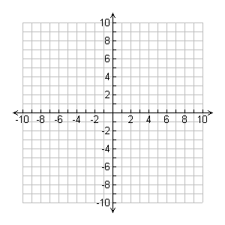
Step Pattern: Step Pattern:

c) $y=2{(x+5)}^{2}$ d) $y=0.5{(x+4)}^{2}+2$

Vertex: Vertex:
Step Pattern: Step Pattern:

3) Find the equation of the parabola with a vertex of (2, 5) through the point (4, 1).
Vertex Form: | $$y=a{(x-h)}^{2}+k$$ | Sketch:
Sub in Vertex:
Sub in Point:
Square and Solve:
Equation:
Equation: $y=____{(x _____)}^{2} _____$

4) Find the equation of the parabola with a vertex of (-2, 2) through the point (0, 6).
Vertex Form: | $$y=a{(x-h)}^{2}+k$$ | Sketch:
Sub in Vertex:
Sub in Point:
Square and Solve:
Equation:
Equation: $y=____{(x _____)}^{2} _____$

5) The school store is now selling t-shirts, and needs to decide on a price. Their goal is to maximize the amount of money they make per month.

You know this bit of market research:

“If you charge $20 per t-shirt, you normally sell 30 every month. Every time you increase the price by $1, you sell one less t-shirt per month. Every time you decrease the price by $1, you sell one more t-shirt per month.”

The question you need to ask is “What price should you charge per t-shirt in order to make the most money possible?

a) Fill in the table below to find out (Mr. Smith has started it for you).

Price per T-shirt | Number of T-shirts sold per month | Total money made per month  (1st × 2nd columns)
$17
$18
$19 | 31 | 31 × $19 = $589
$20 | 30 | 30 × $20 = $600
$21 | 29 | 29 × $21 = $609
$22
$23
$24
$25
$26
$27
$28

b) How much should you charge per t-shirt to maximize how much money is made?

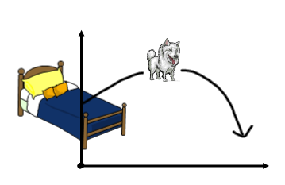
6) Mr. Smith’s dog Rosie launches off the bed, through the air to get a treat that Mr. Smith tossed. Her height above the ground can be modelled by the equation
h = -5(t – 0.4)² + 1.7

Where h is in metres, and t is in seconds.

a) What is the vertex of the relation described above?
b) Fill in the blanks. Rosie reaches a maximum height of __________ meters after _______ seconds.

7) Create a table of values for the following relation: $y=(x-2)(x-4)$ and sketch the relation on the graph provided:

x | $$y=(x-2)(x-4)$$ | Point
0 | y = (0 – 2)(0 – 4) = 8 | (0, 8)
1
2
3
4
5

Note: We will be investigating relations of this form tomorrow!

