The following task contains a mixture of trigonometry problems through our first unit. Like the warm-up, you will need to choose an appropriate tool, or tools to help you solve the problem. Each question is worth 5 marks. For full marks, you need to show your work in detail, and make a very brief concluding statement.
/20
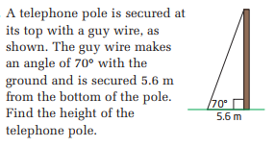
1)

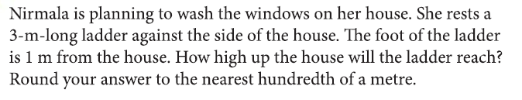
2)

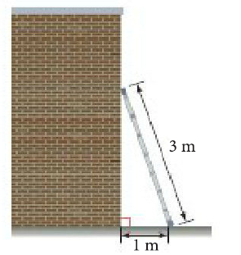

3) A boat leaves a port at Jamestown (J) for the port at Puerto Rico (P). Due to strong currents, they wind up 5km west of their destination. How many degrees west of north did they go off course?

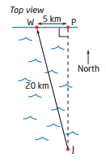

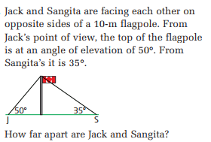
4)

