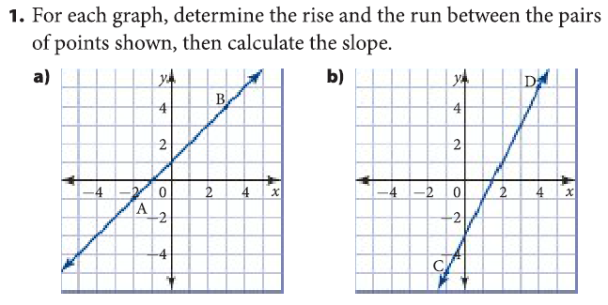
a) |  |  | b)
Rise | Run | Slope | Rise | Run | Slope
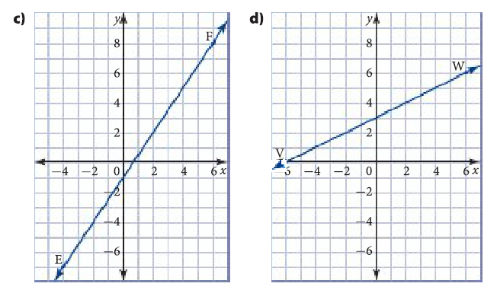

c) |  |  | d)
Rise | Run | Slope | Rise | Run | Slope

A relation is just a relationship between two variables (often we use x and y). In this warmup you will get used to the Cartesian plane, and then look at some relations in 4 different ways:

- An equation
- A written rule
- A table of values
- A graph

3) For the following two relations, complete the table (like our warmup) and find the slope of each line.
Relation #1
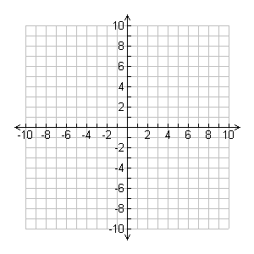
Equation: $y=2x+5$
Written Rule: |  |  | Graph:
x | y
-3
-2
-1
0
1
2
3
Rise = |  | Run = |  | Slope =

Relation #2
Equation: $y=4x-2$
Written Rule: |  |  | Graph:
x | y
-3
-2
-1
0
1
2
3
Rise = |  | Run = |  | Slope =

