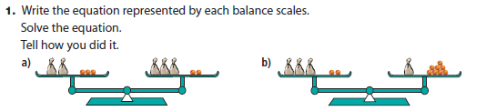

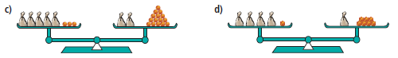

1a) 2x + 3 = 3x + 2 ; x = 1
b) 3x + 2 = x + 8 ; x = 3
c) 5x + 3 = 2x + 15 ; x = 4
d) 4x + 1 = x + 7 ; x = 2
2a) x = 7 b) x = -4 c) x = -6
3a) x = -7 b) x = 4
c) x = -1 d) x = 6
Extra Practice:
4.
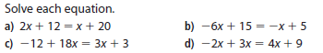

5. Solve each equation
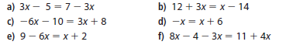

4a) x = 8 b) x = 2 c) x = -2 d) x = -3
5a) x = 2 b) x = -13 c) x = -2 d) x = -3
e) x = 1 f) x = 15

