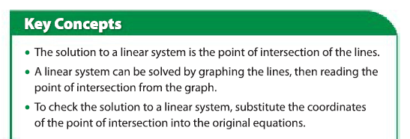

1) Find the solution of the following linear systems. Remember that you will need to determine the slope and y-intercept of each line first.

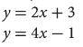
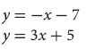
a) b)

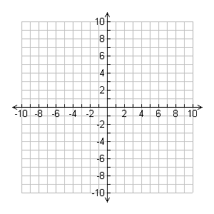
Sketch: Sketch:

Point of Intersection: Point of Intersection:

Am I Right?? Check your answer to part a)
Line #1 | Line #2

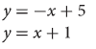
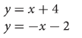
c) d)

Point of Intersection: Point of Intersection:

e) $y=\frac{1}{3}x-4$ f) $y=\frac{1}{4}x-3$
$y=-\frac{1}{2}x+1$ $y=-\frac{3}{8}x+2$

Point of Intersection: Point of Intersection:

Answers: a) (2, 7) b) (-3, -4) c) (2, 3) d) (-3, 1) e) (6, -2) f) (8, -1)

2) Solve the following linear systems using algebra. Mr. Smith has provided a table for you for the first few.

a) $y=2x-5$
$y=5x+7$
1) Set the equations equal, and solve for “x” | 2) Sub your value for “x” into either equation
Point of Intersection = ( , )

b) $y=10x+5$
$y=8x+17$
1) Set the equations equal, and solve for “x” | 2) Sub your value for “x” into either equation
Point of Intersection = ( , )

c) $y=0.5x-2$
$y=1.5x+3$
1) Set the equations equal, and solve for “x” | 2) Sub your value for “x” into either equation
Point of Intersection = ( , )

d) $y=-3x+25$
$y=4x+4$
1) Set the equations equal, and solve for “x” | 2) Sub your value for “x” into either equation
Point of Intersection = ( , )

e) $y=0.1x+2.5$
$y=0.5x+2.1$
1) Set the equations equal, and solve for “x” | 2) Sub your value for “x” into either equation
Point of Intersection = ( , )

f) $y=\frac{1}{2}x+2$
$y=2x-7$

g) $y=\frac{3}{4}x+1$
$y=3x-8$

h) $y=0.2x+2.7$
$y=0.5x+2.4$

i) $y=0.12x+0.45$
$y=0.25x+0.19$

Solutions to #2: a) (-4, -13) b) (6, 65) c) (-5, -4.5) d) (3, 16) e) (1, 2.6) f) (6, 5)
g) (4, 4) h) (1, 2.9) i) (2, 6.9)

