We started off this Statistics Unit by interpreting and constructing graphs. On your test, you would be expected to interpret the following graphs.

- Bar Graph
- Double Bar Graph
- Line Graph
- Double Line Graph
- Circle Graph
- Histogram

You may be asked to make the following graphs.

- Bar Graph
- Double Bar Graph
- Line Graph
- Double Line Graph
- Histogram

Example: Which type is each of the graphs drawn below. After you have identified each type, we will briefly describe when each one is useful.
Graph: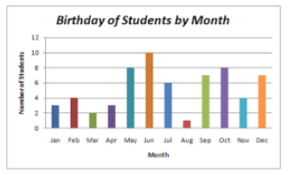 | Graph: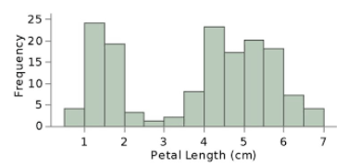
Type: | Type:
When is it used? | When is it used?
Graph:  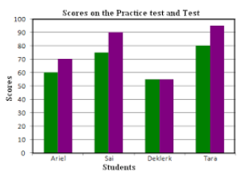 | Graph:  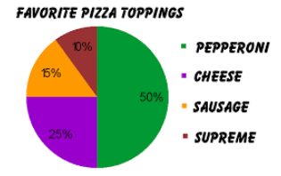
Type: | Type:
When is it used? | When is it used?
Graph:  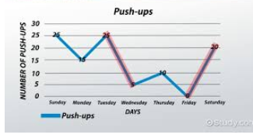 | Graph:  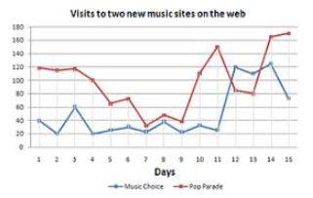
Type: | Type:
When is it used? | When is it used?

Histograms came in 6 different shapes or distributions:

- Normal
- Skewed
- Bimodal
- Plateau
- Heart-cut
- Dog Food

Example: Which type of distribution are the following?
Histogram:  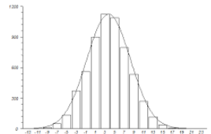 | Histogram:  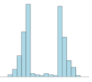 | Histogram:  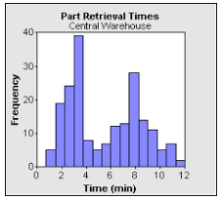
Type: | Type: | Type:
Histogram: | Histogram:  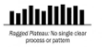 | Histogram:  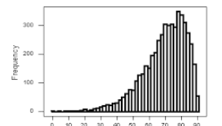
Type: | Type: | Type:

We briefly talked about two ways that graphs could be misleading:
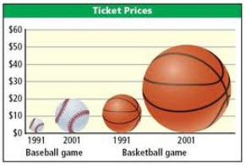
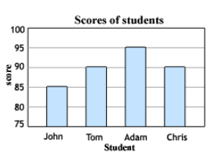
1) 2)

You will describe how a graph could be misleading on your unit test.
After talking about how to display and interpret data, we talked about analyzing it by calculating statistics. We reviewed how to calculate the mean, median, and mode.
Mean –
Median –
Mode –
Example: Find the mean, median, and mode of this set of data. You have to sort it first to find the median!
45 | 76 | 65 | 76 | 55 | 59 | 76 | 65 | 72 | 68

We also talked about how to estimate a mean and median if you had grouped data, or a histogram.
KEY IDEA:
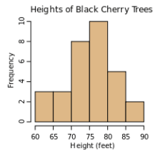
Example: Estimate the mean and median black cherry tree height from this histogram.
a) How many trees are represented in this diagram?

b) Which tree would be in the middle?

c) Estimate the mean tree height.

