1) Find the surface area of the following basic 3D shapes. You will need to identify the shape and choose the appropriate formula:

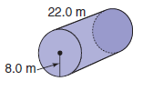
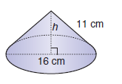
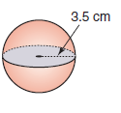
a) b) c)

2) Find the surface area of the following composite shapes. Count the entire outside of the shape.

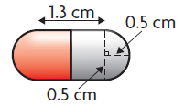  Visual: A pill | Spherical end surfaces: | Cylindrical middle surface:
Area of Surface:
Total Surface Area =

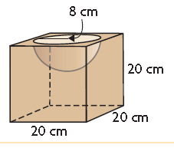  Visual: A cube with a hemisphere cut out | “Cube Surface” | “Hemisphere Surface”
Area of Surface:
If you add the surface area of the cube, and hemisphere. You are counting the circular opening (which isn’t part of the surface). In this space, calculate the area of that circle.

Total Surface Area =

3) Consider the paper cup diagrammed below. For obvious reasons the cup will have no top. Determine the amount of paper needed to make the cup.

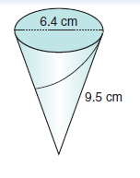

4) How much material would be required to make this tennis ball?
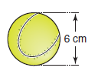

5) How many cm² of glass would be needed to make the “cup” portion of this glass? You can ignore the stem.

Level R | Level 1 | Level 2 | Level 3 | Level 4
Task is incomplete. Work is very unorganized and hard to follow. Mr. Smith may ask you to redo it. | Calculations have major errors. Work is somewhat organized. Instructions were not followed well. Major notation issues. | Calculations have minor errors. Work is somewhat organized. Minor notation issues. Instructions were followed for the most part. | Calculations have minor errors. Work is organized. Proper notation is used. Instructions were properly followed. | All calculations are correct. Work is well organized and proper notation used. Instructions were followed meticulously.

Bonus 1: Consider the tennis ball from earlier…
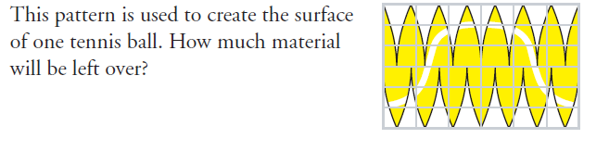
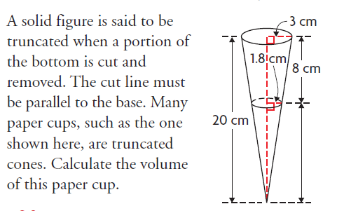
Bonus 2:

Bonus 3: Do the surface area too!

