Calculate the surface area of the following prisms using the method of your choice. You do not need to draw a net if you prefer not to.
1) Find the surface area of this rectangular prism
Method 1: Use a net and a table
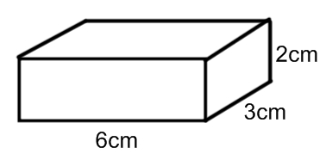  Shape: |  | Net:
Basic Shape #1 | Basic Shape #2 |  | Basic Shape #3
Area = | Area = |  | Area =
Total Area (2 of each rectangle) =

Method 2: Use the formula $SA=2(l×w+l×h+w×h)$

2) Find the surface area of this triangular prism.
Method 1: Use a net and a table
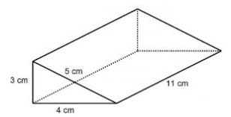  Shape: |  | Net:
Basic Shape #1 | Basic Shape #2 | Basic Shape #3 | Basic Shape #4
Area = | Area = | Area = | Area =
Total Area (2 of each triangle, and 3 different rectangular sides) =

Method 2: Use the formula $SA=ah+bh+ch+bl$

3) Find the surface area of this cylinder
Method 1: Use a net and a table
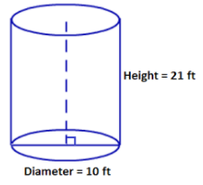  Shape: | Net:
Basic Shape #1 | Basic Shape #2
Area = | Area =
Total Area (2 circles and the rectangle)

Method 2: Use the formula $SA=2×π×r^{2}+2×π×r×h$

4) For the following 3D shapes, determine the surface area using the method of your choice.
1) Determine the surface area of each prism. Note that for e) and f) you will need to use Pythagorean Theorem to find the height of the triangular faces.

(height of base is 1.94yd) (height of base is 19.05cm)

Numerical Answers: 1) a) 1608 in² b) 112 yd² c) 21.42 m² d) 1312 cm² e) 16.94 yd² f) 2069.2 cm²

