Create a table of values for the following 3 relations (decimals are OK for the third). Calculate the first and second differences for each relation. Then, graph them on the provided grid.
Relation: $y=2x$ |  |  |  | Graph:
$$x$$ | $$y$$ | 1st Diff. | 2nd Diff.
-3
-2
-1
0
1
2
3

Relation: $y=x^{2}$ |  |  |  | Graph:
$$x$$ | $$y$$ | 1st Diff. | 2nd Diff.
-3
-2
-1
0
1
2
3

Relation: $y=2^{x}$ |  |  |  | Graph:
$$x$$ | $$y$$ | 1st Diff. | 2nd Diff.
-3
-2
-1
0
1
2
3

2) Describe the 4 transformations from the basic parabola $y=x^{2}$ that the following quadratic relations undergoes: $y=-3{\left(x+2\right)}^{2}+5$

3) Graph the following two quadratic relations:
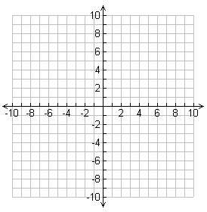
a) $y=1.5{(x-4)}^{2}-2$ b) $y=-2.5(x-1)(x+3)$

4) Find equation (in vertex form) of a parabola with a vertex of (5, 4), with a y-intercept of 16.5.
5) Find the equation (in factored form) of a parabola with x-intercepts of 5 and -1, with a maximum value of 10.

