1) Expand the following 2 quadratic relations to convert them into standard form. Make a graph of the parabola so that you can check your answer.

a) Vertex Form: b) Factored Form: Sketch:

2) Expand and simplify the following expressions:

a) b)

3) Evaluate the following by rewriting with positive exponents first. Leave your answer as a fraction instead of a decimal where applicable.

a) $6^{-3}$ b) ${(-5)}^{-4}$ c) ${(7^{-1}+2^{-3})}^{0}$ d) ${\left(\frac{5}{4}\right)}^{-3}$

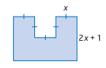4) Write an algebraic expression for the area of the following figure. Expand and simplify. Then, find the area in another way to verify your result.

5) What is the standard form, factored form, and vertex form of the quadratic relation graphed below.

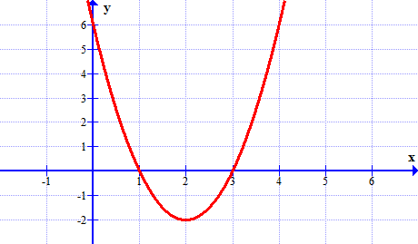

|  |  |  |
| --- | --- | --- |
| Standard Form | Vertex Form | Factored Form |
|  |  |  |