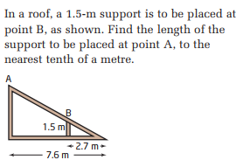
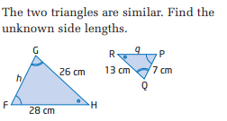
1) 2)

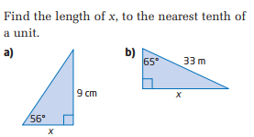
3)

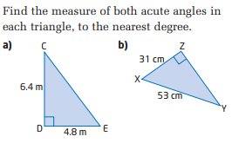
4)

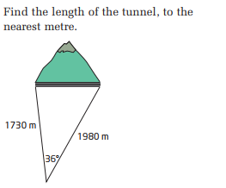
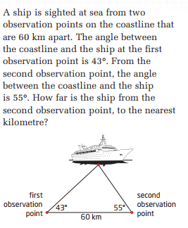
5) 6)

7) Solve the following triangle. Round answers to the nearest tenth of a degree.
In the acute triangle ABC, a = 6.8 cm, b = 8.7 cm, and c = 9.6 cm.

